Social media

Training materials | Version 2  5 2019

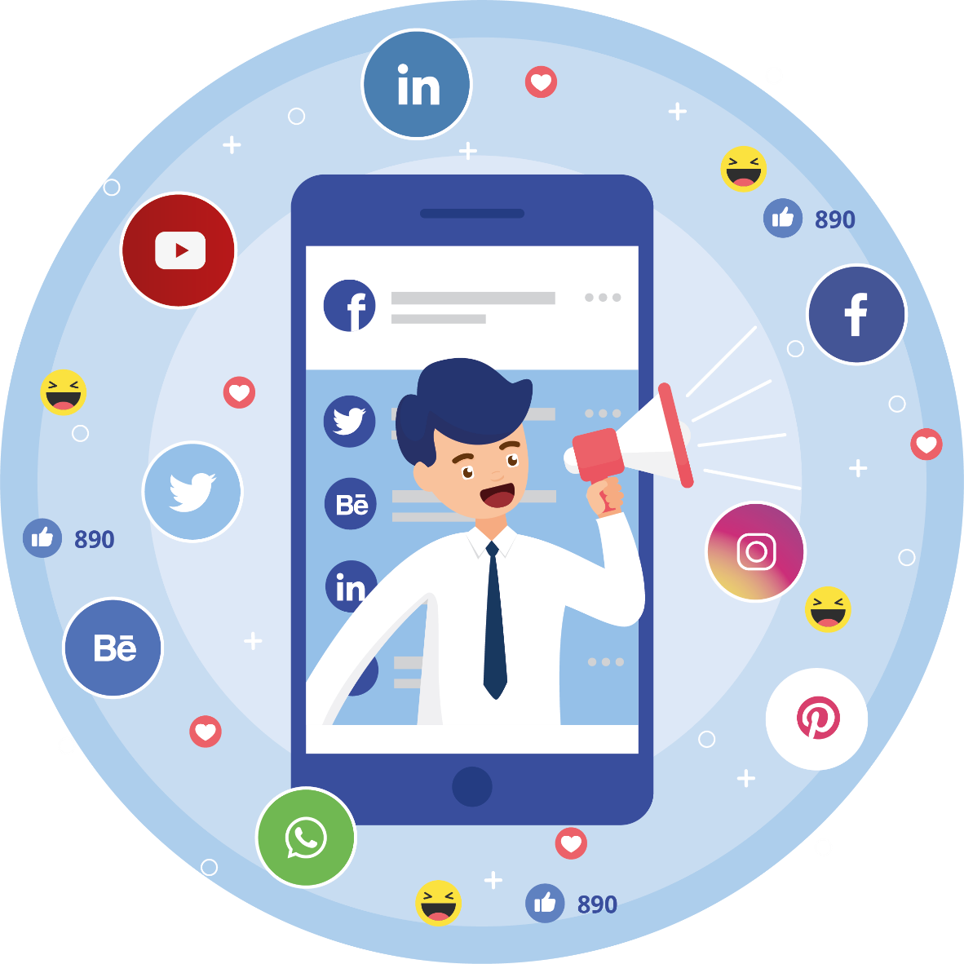

Table of contents
Introduction 3
A. Basic information 4
1. Why social media and which one to choose 4
2. Creating a fanpage 7
3. How to start 11
4. Configuration of Messenger 17
5. Publication and distribution of content 20
6. Facebook algorithm 29
7. How to create engaging content 32
8. How to finish 38
9. Instagram - creating an account 38
10. How to successfully run an Instagram account 40
11. LinkedIn - creating an account 41
12. How to successfully run a LinkedIn account 47
B. Further information 50
13. Analytics 50
14. Paid promotion 58
15. Twitter - creating an account 69
16. How to successfully run a Twitter account 75
17. Bibliography 78

Introduction
Social networks are one of the most popular communication platforms in today's world. What sets them apart is that they are almost entirely created by users on an equal, democratic basis - there is no single central broadcaster, but millions of individual people who share information with each other.
The most popular social media, such as Facebook and Instagram, are the perfect place for the creators of culture. They are not professionally profiled (as are Twitter or LinkedIn, for example), but for most users they are a source of entertainment, information and sharing of their thoughts, which is a wonderful context for the reception of all types of culture-related messages.

- Basic information
- Why social media and which one to choose
Social media are gaining ever more importance from year to year especially in comparison to traditional media. It can be suspected that in the following years this trend - although it may not be with such high dynamics - will continue to exist. This state of affairs means that every person or entity who wants to reach a wide audience should use social media.
Being present in social media brings many different benefits. They allow the achievement of various marketing goals, such as building awareness among recipients, the possibility of using new communication channels or reaching a specific group of recipients - all of this could also be achieved through traditional media. Social media, however, bring a whole new dimension to this, which has both good and bad sides.
Advantages:
- direct contact with recipients;
- large reach of information;
- large group of recipients;
- speed of distributing information.
Disadvantages:
- threat of emergence of crises;
- information noise;
- lack of full control over the information provided.
There is no doubt, however, that it is worth being present in social media. However, a larger problem can be caused by the question - on which exactly? When choosing the best social platform for your needs, you should analyze and ask yourself a few questions. First of all, we should know who we want to reach, what message to form, in what form we will create messages (text, video, photos), what effects we want to achieve (to exist in the audience's awareness, create an image as a topic expert, make contacts or build a community). Knowing the answers to these questions and the specifics of individual social networking sites, it will be easier for us to choose those that will be most useful for achieving the goals set for us.
But even then, the choice may not seem clear. Every human activity is multidimensional and therefore requires the accomplishment of many different goals. Sometimes setting up on only one portal will limit us, which is why in most cases multiplatform activity is recommended, i.e. using different channels that will serve different purposes.

Figure 1. Social media as a source of information
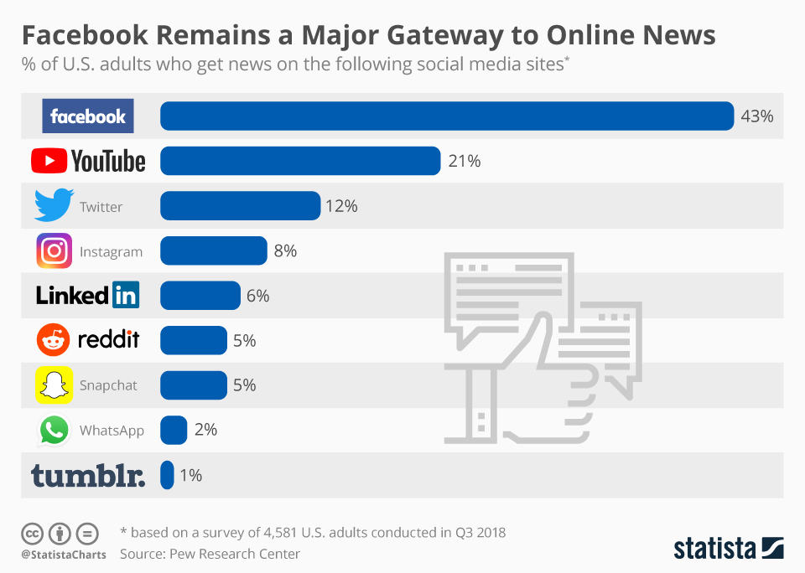
Source: https://www.statista.com/chart/16304/social-media-as-a-news-source/
There are many social media sites on the Internet. Some of them are for entertainment only, others for expert and business purposes; some of them are easy to use, others are extremely powerful tools. It is impossible to cover all of them, so in this document we will discuss only a few selected most popular social networks. These are:
- Facebook,
- Instagram,
- LinkedIn,
- Twitter.
Why Facebook?
Facebook is a very sophisticated and versatile medium, and in addition it is still the most popular (and with a big advantage over other portals). All this makes a fanpage on Facebook the first and obligatory choice among all of the available platforms. It will be useful for conducting any kind of activity, and certainly it will be one of the most important channels for creators of intangible culture. That is why we pay so much attention to it in this document, discussing the issues in detail in the following chapters.
Why Instagram?
Instagram is still an underestimated social medium. This is unfair - although indeed Instagram cannot match Facebook in terms of reach (getting to the number of recipients), the content published on this platform is more engaging for users. On Instagram, we can count on more likes and comments. According to research, users of this portal are 3 times more active than Facebook users.
Instagram is a perfect place for the creators of intangible culture. This is supported by the specificity of this portal - it is largely focused on entertainment, it is dominated by single photos, short films and publications with a specific access time (i.e. the so-called Instagram Stories, which are deleted after 24 hours). If we have attractive photos or video presenting the effects of our creative work, there is no better place for their publication than Instagram.
Why LinkedIn?
LinkedIn is a social network with a clearly different profile than Facebook or Instagram. In contrast with them, it is hardly oriented to entertainment at all, and focuses primarily on professional and business issues. It is a portal for professionals to share their knowledge and present their own achievements and skills. It is no wonder, then, that this portal is particularly liked by recruiters.
This does not mean, however, that it is not a portal that is useful for the creators of intangible culture. Every type of activity - including cultural - takes place in a free market, in which big business plays an enormous role. Large companies can become our patrons, partners and use our services on a large scale. Apart from the creator's commitment and creativity, art also needs money. LinkedIn is, therefore, a good chance to establish contacts that may result in interesting and lucrative cooperation for us in the future. This is worth remembering especially in the context of the fact that people active in art rarely decide to use this portal, because it seems unattractive and completely useless in the implementation of their creative ideas.
Why Twitter?
Twitter, due to its specificity (its focus on text and the very limited number of characters) is an extremely characteristic medium. Politicians, journalists and experts are happy to use it, often exchanging information and views regarding a given area of ​​reality. Such a view may suggest that it is a portal similar to LinkedIn. This is a misconception - Twitter, despite the subject matter, is not so focused on a professional message. It is often a place of ardent polemics, expression of personal opinions and a source of the latest news. It is therefore an ideal medium for a quick and spontaneous exchange of thoughts, opinions and information. It is rather unsuited to precise (as regards day and time) communication strategies, because they will destroy the naturalness of communication. So if you feel that you have something to say in the area of ​​culture in which you operate, be sure to create a Twitter account. Form messages freely, share curiosities, spread the news you have heard, comment on a controversial topic, engage in polemics, respond to other people's posts. This is what Twitter users expect.
- Creating a fanpage
Let's start with Facebook. To start communication within the environment, it is necessary to set up a fanpage (that is, an official account that can be dedicated to a company, institution or person - in contrast to a private account, which is dedicated only to a person). On the Facebook platform it comes down to a few simple steps, the first of which is to click "Create" in the main menu and select "Page" from the drop-down list.
Figure 2. Creating an account - step 1
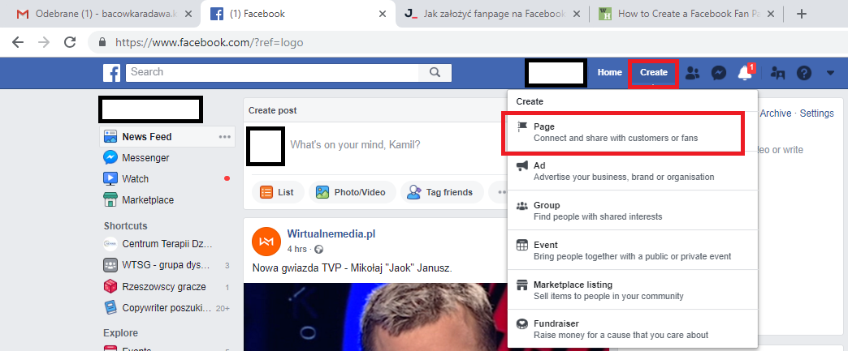
Source: own work
In the second step we have a choice:
- A company or brand - dedicated to companies, institutions, brands such as art galleries, museums, theaters, cultural centers, associations,
- A community or a public person - dedicated to people and groups of people, e.g. dance groups, or individually - creators of culture.

Figure 3. Creating an account - choosing the type of fanpage.
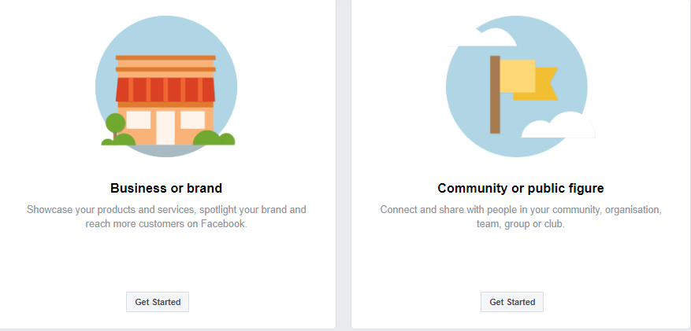
Source: own work
We choose one of the options and fill in two fields:
- Name - we give the name of our fanpage;
- Category – we enter one or two words and choose from the list of proposed categories that describe the subject or specialization of our activity.
Figure 4. Creating an account - name and category
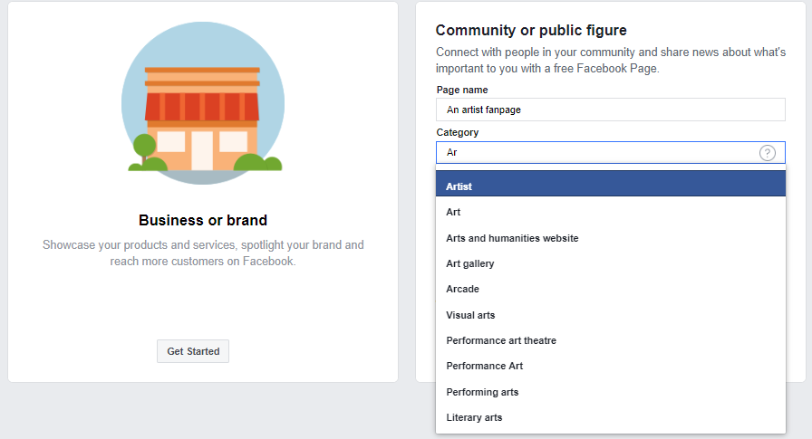
Source: own work

Profile image - it is recommended to publish a logo in the case of institutions, whereas in the case of artists/creators it may be a typical profile picture of a person, a work created or a group of people (in the case of a team).
Dimensions: the displayed size is 180x180px (px - pixels - the smallest uniform elements (one-color squares), which make up the image displayed on the monitor); however, you can add larger pictures in a square format (e.g. 320x320px or 960x960px). Instead of a picture, you can also add a 7-second film, which will be a feature that distinguishes a given fanpage from others.
It should be added here that although Facebook has precisely defined optimal graphic dimensions, it can also adapt files that do not fully meet the requirements. However, this may cause the algorithm that adjusts the graphics to distort it, which will cause it to lose aesthetic value, e.g. it will be illegible or cut off in the wrong place.
Figure 5 Creating an account - uploading a profile picture
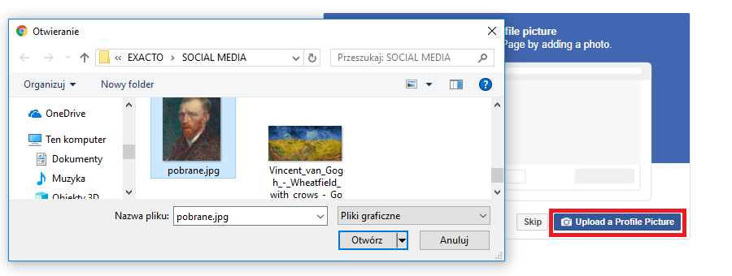
Source: own work
The next step will be uploading a background image - it is worth adding a picture showing a wider context – a cultural institution’s building or an artist during a performance or work. The background pictures should be first of all eye-catching and visually appealing. It is worth adding that both steps related to adding pictures can be omitted on the Facebook platform; however, this is not recommended, because it is worth taking care of the visual side of the page from the very beginning of the creation of the profile.
Dimensions:
- 820x312px - computers and laptops;
- 640x360px - smartphones;
- 400x150px - minimum background picture dimensions.
The optimal size that will allow for correct display on both computers and telephones is: 820x462px - of course, it should be remembered that on the computers the image will be cut slightly from the top and bottom, therefore, when planning graphics, this should be taken into account (see Figure 6). Despite this inconvenience, it is still the most optimal solution for all platforms.
Figure 6. Optimal background image dimensions
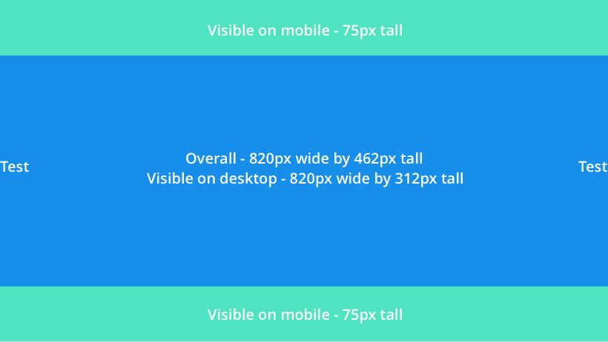
Source: buffer.com
As with a profile picture, you can also upload a video file in the background. The optimal parameters of such a video are:
- Dimensions: 820x462px;
- Length: 20-90 seconds.
The given dimensions may change because Facebook constantly tries to optimize the appearance of the portal, so the sizes and formats displayed may change. Sometimes, for example, profile pictures are displayed in circles, not squares. Usually, these are not radical changes. It is worth remembering, however, that an image which has been displayed correctly so far may have its display area changed at some point. The graphics should then be adjusted to the updated Facebook requirements.
Congratulations! You have created a fanpage!
Figure 7. Shortcuts leading to your fanpage
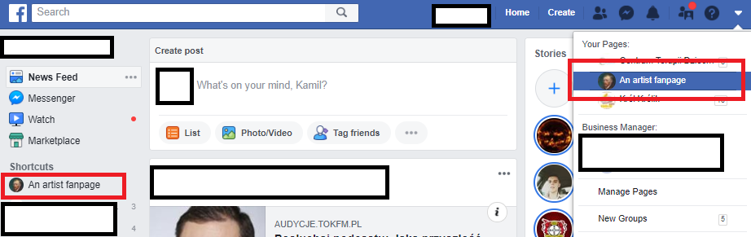
Source: own work
Now we still need to configure our fanpage to optimize the effectiveness of its reach and users' involvement in the published content.

- How to start
From the very beginning, Facebook wants to make it easy for new users to start, and so they prepare advice and suggestions that are worth following. The first step in building a community should be to invite our own friends and colleagues (see Figure 7).
Figure 8. Inviting friends
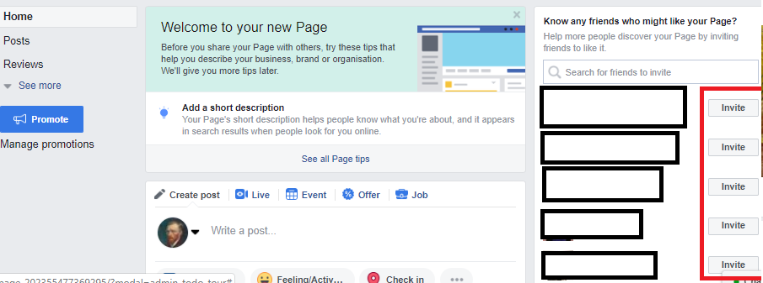
Source: own work
Once we have invited friends to like our fanpage, it's worth ensuring that others can find it more easily. For this purpose, we can change the complicated link that leads to our page to one that is simpler and easier to remember.
To optimize it, go to the "About" tab on the left, then select "Create Page @username".

Figure 9. Link optimization
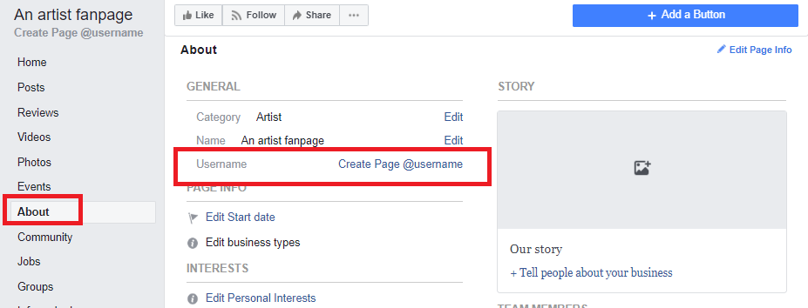
Source: own work
In the "Username" field, enter a string of characters that will be a simplified system name of our fanpage (used, among others, for tagging it). The upper limit for the name is 50 characters, and the lower limit is 5. The usernames can only consist of alphanumeric characters (A-Z, 0-9) and dots ("."). They cannot contain general expressions or extensions (.com, .net). In addition, the name must be unique (it cannot have already been taken by anyone else).
Figure 10. Changing username
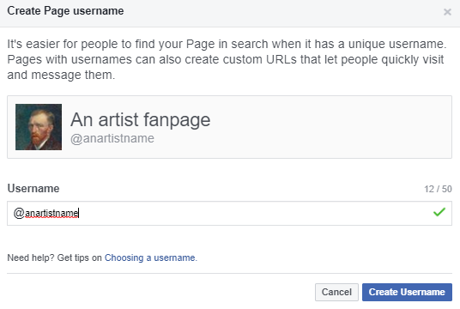
Source: own work
After completing the above steps, we obtain a shorter, easier to remember, username. A comparison of both types of link is provided in Figure 10.

Figure 11. Comparison of original and abbreviated links
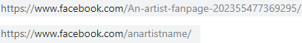
Source: own work

Since we already have an optimized link, let us now add a button that simplifies the performance of an action chosen of our choice by visitors to the page. To do this, click the "+ Add a Button" button.
Figure 12. Adding a button
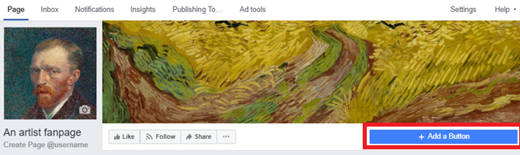
Source: own work
A menu will be displayed which will allow us to configure the button in two steps. The first step is selecting what action to initiate when a visitor clicks the button when visiting our site. Options:
- Make a booking with you ("Book a date");
- Contact you ("Contact");
- Learn more about your company ("More about the company");
- Shop with you or make a donation ("Local purchases");
- Download your app or play your game ("Download your app or play your game").
For the purpose of this exercise, we choose the "Contact" option. In this case, we again get to choose:
- Contact Us - transfers to the website indicated;
- Send Message - allows you the visitor to send a message via Messenger;
- Call Now - allows you to call the number indicated;
- Sign Up - transfers to a subpage with the option of registration and login;
- Send Email - allows the visitor to send a message to the given e-mail address.

Figure 13. Selecting a button
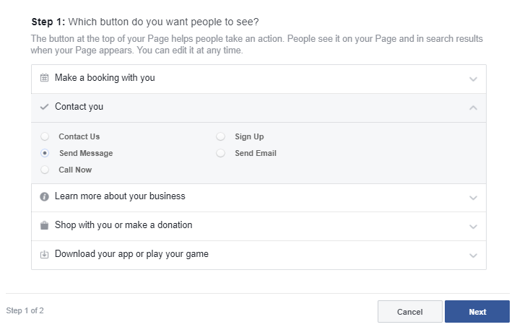
Source: own work
This time, we choose the "Send Email" option. Here we can change the text on the button - if we want to change it, we click the "Edit" button level with "Your button Send Email". The second part is, however, more important, where we give the destination email address at which we want to receive messages. We complete this field, save and finish the whole procedure.
Figure 14. Creating a button leading to an email address
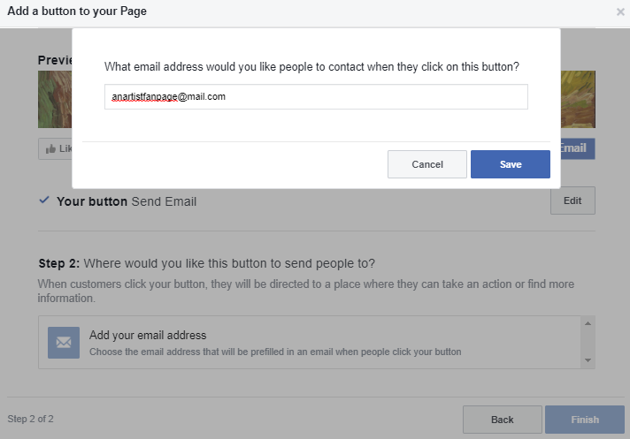
Source: own work
We have managed to create a button! If a different or additional button will be useful for a given page, the process of creating it will be analogous. We should choose the option that will make it easier for users to use the page and that will be the most profitable for us.

Exercise
Test the other button options:
- Which one will be the most useful for your users?
- What is important to you? E-mail messages, telephone contact, providing additional information about the company, your own work, receiving financial support?
- Consider the text on the button - an effective "call to action" (that is expressed in the form of a sentence in the imperative, e.g. "Sign Up!") will help you attract more people to take advantage of this solution.

Another page worth visiting in the settings is "Page Info". This is a place that allows us to fill in the most basic information about our fanpage, that is, provide:
- short description;
- telephone number;
- email address;
- website address;
- interests;
- location;
- opening hours.
Filling in this information will help users to search for more detailed information about our company.
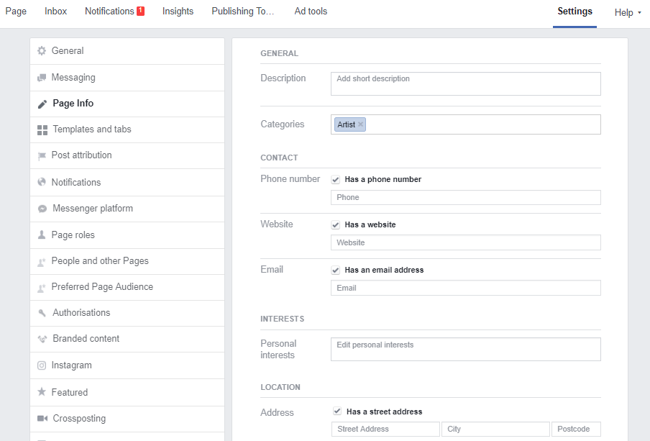
Figure 15. Basic information
Source: own work
The final tab that is worth checking at the very beginning of the fan page’s existence, is "Page roles", where we can assign roles to other users on the site to run the profile. This is more useful in the case of fanpages of cultural institutions than individual artists. However, it may happen that the creator will work with a marketer who will take care of the profile - then it will be necessary to assign the said marketer to the site.
Roles available on the page:
- Administrator;
- Editor;
- Moderator;
- Advertiser;
- Analyst.
The most important role on the site is the role of the Administrator - he has full authority. At the beginning, the creator of the fanpage - as the first and only person managing the profile – is automatically given this role. There can be more than one administrator on one fanpage; however, this role should be assigned very sensibly, only trusted persons should receive it. The details of individual roles on Facebook are presented in Table 1.

Table. 1. Roles on the site and their rights
Task Role | Administrator | Editor | Moderator | Advertiser | Analyst
Managing roles on the page and settings | ✔
Editing a page and adding applications | ✔ | ✔
Creating and deleting posts on behalf of the site | ✔ | ✔
Sending messages on behalf of the site | ✔ | ✔ | ✔
Responding to comments and deleting comments and posts from the site | ✔ | ✔ | ✔
Blocking people and deleting them from the site | ✔ | ✔ | ✔
Creating ads, promotions and promoted posts | ✔ | ✔ | ✔ | ✔
Viewing statistics | ✔ | ✔ | ✔ | ✔ | ✔
Checking who added a post on behalf of the site | ✔ | ✔ | ✔ | ✔ | ✔
Publishing and managing job offers | ✔ | ✔
Source: Facebook Help Center.

- Configuration of Messenger
Let's move on to Messenger, which is the most important application for many Facebook users. Users of this platform like fast and effective communication, which is why it is always worth keeping your finger on the pulse. However, we are not able to respond to messages received 24 hours a day, so it is worth supporting solutions that will facilitate communication with users and improve response statistics. One such simple solution is setting up an autoreply when we are unable to respond (e.g. at night). To find this solution:
- click on "Settings";
- then in the left column "Messaging";
- at the end, in the "Appointment Messaging" area, click "Jump to Section" (the entire operation instruction is presented graphically in Figure 14).
Figure 16. Setting up the autoreply
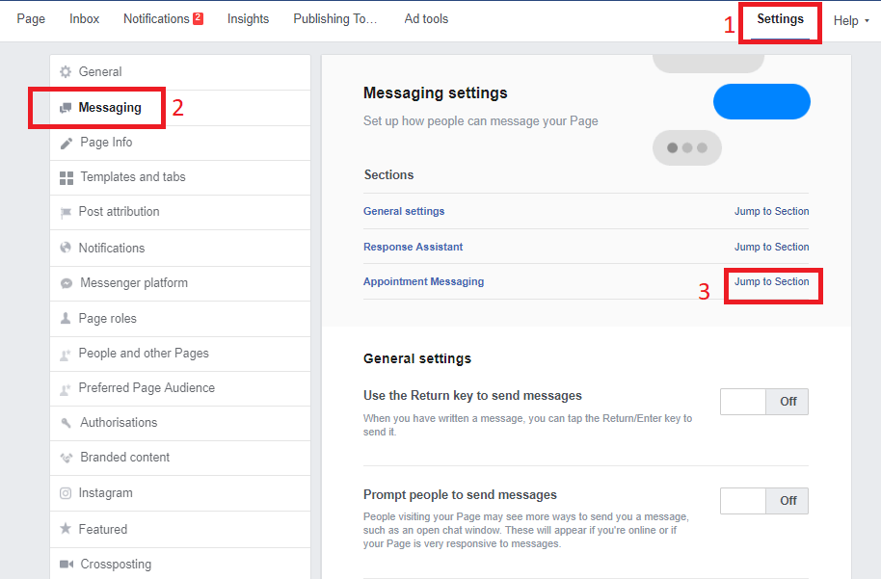
Source: own work
Once we are in the "Appointment Messaging" section, we run the "Stay responsive when you do not have access to your computer or phone" option. Then click the "Change" button, which will appear after enabling this option, we will now be able to configure our autoreply. In the "Message" tab we can edit the broadcast content, and in the "Schedule" tab, specify when it should be sent.
Figure 17. Setting the time for autoreply
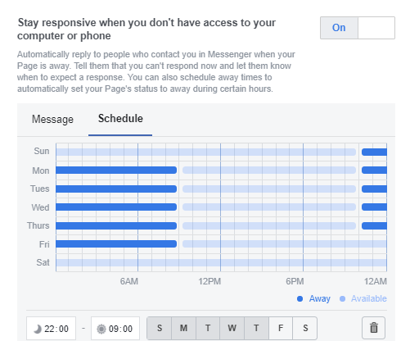
Source: own work
As can be seen in Figure 15, the autoreply will be sent only at night from 22:00 to 9:00 in the morning. However, the autoreply will not be sent over the weekend, i.e. on Saturday and Sunday.

Exercise:
Set up your own autoreply:
- Develop your own message content. Pay attention to the personalization options offered by the Messenger application.
- Specify the time when the automatic message should be sent. Will it be night hours? Or maybe hours after work? What about weekends?

More advanced users can try to program their own chatbot, which will conduct simple conversations with users, answering their most frequent questions (previously defined during programming). It should be remembered that this is not a model of advanced artificial intelligence, which runs complex conversations by itself, only a simple program displaying prepared answers on selected issues.

- Publication and distribution of content
Since we already have basic solutions, it's time to get started with what social media really are - publication and distribution of content (information). Let's create our first post. This is done in exactly the same way as on private profiles. All we have to do is click on the window that encourages us to publish ("Write a post ..."), so that a tool will open up that guides us step by step until we post our content on the page/profile.
Figure 18. Adding a post
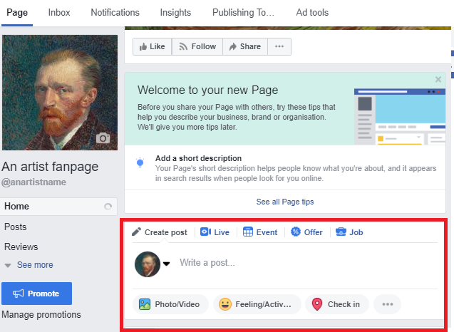
Source: own work
In the text field we can fill the post with content in the form of characters and emoticons. This field can be empty, if you want to create a post only from, for example, pictures, but this is not recommended. It is always worth adding a few words of description or comment to our posts - be it a photo gallery or a video file - because this type of content is more engaging. In addition, you can encourage visitors to become acquainted with your visual materials, for example, "it's worth watching until the end! The ending will surprise you"- of course if that is true. Otherwise, we will create in our recipients expectations that will not be satisfied, which exposes us to unfavourable comments.
Just as publishing visual materials without a written comment is unprofitable, written content alone will have a difficult task to gain broad access to social media users. Modern visual culture somehow enforces the use of graphics, because without them text is not very attractive. In addition, there is the issue of the Facebook algorithm - which we will describe in the next chapter.
Returning to the preparation of a post - let's add some photos. To do this, click the "Photo/Video" button.
Figure 19. Creating post content
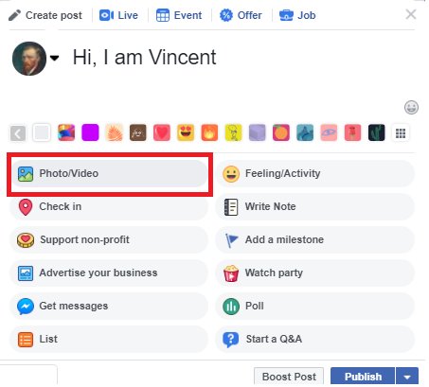
Source: own work
We will have 4 options to choose from:
- Upload photos/video - the most popular option, allows us to add photo files or a video file;
- Create Photo Album - allows you to create a photo album, in practice a folder that serves to organize and catalog our photographs;
- Create slideshow - allows you to create a slideshow, which will consist of from 3 to 10 photos. The slide show options include the length of displaying one image (from 0.5 seconds to 5 seconds), setting the aspect ratio (original, 1:1 square, 16:9 rectangle, 2: 3 vertical), transition type (none or disappearing) and music (our own or from Facebook's audio database);
- Create an Instant Experience - this more advanced option allows us to create our own type of post, which will consist of connections of various elements we that have selected - photos, videos, buttons, slide shows - at our discretion.
We chose option 1 - "upload photos/video".

Figure 20. Options for adding visual content to a post
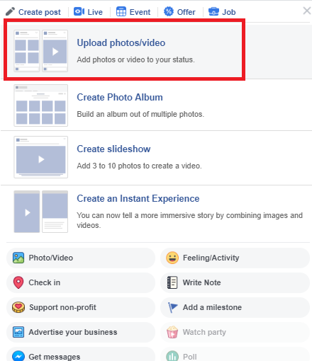
Source: own work
We search for interesting visual materials from the disc. At the beginning, we will add one file.

Figure 21. Adding a photo
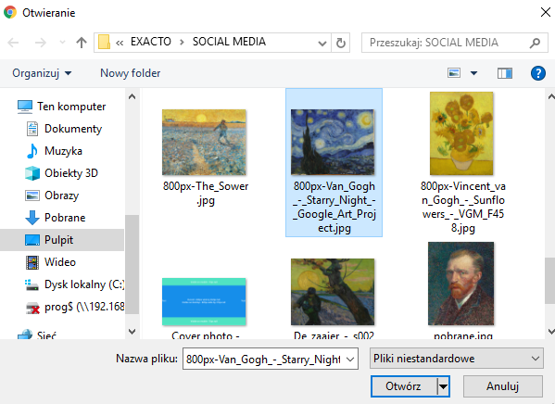
Source: own work
One work by our artist/creator has been attached to our post. However, if we want to add more, just click on the plus icon next to the photo.
Figure 22. Adding more photos (+)
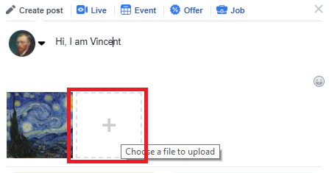
Source: own work
In the file opening window we can select several photos at once. Just click on the next files with the CTRL button pressed at the same time. Once we have selected a few photos, they will be placed in a queue. This decides the order in which the uploaded files are displayed - the files on the left are displayed first, then the next files to the right. The main picture should always be on the left. We want the famous sunflowers to be the most important photo, which is why we move them to the beginning of the queue. To do this, click on the thumbnail of the sunflowers and holding the mouse button move them to the left.
Figure 23. Changing the order of photos
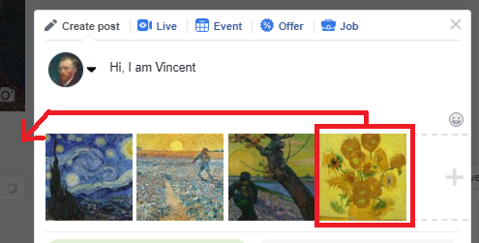
Source: own work
Once we have arranged the photos according to the order of our choice, we click "Publish" and we can already enjoy the effect of our work. Sometimes, after publishing the post, however, we will want to do something else with it. The additional possibilities are:
- Pin to top of page - pins the post at the top of the page. This option is useful when you want some content to be displayed for a certain time on your page. This is useful in the case of important announcements, e.g. contests, planned events;
- Edit post - this option allows you to edit the contents of the post. Unfortunately, you cannot add or delete photos, you can only change the written description of the post; however, it is recommended not to use this option and not to make big changes to the post after its publication - this is not well perceived;
- Change date - allows you to change the publication date of the post;
- Embed - embeds and displays the link code, which we can paste and insert into our external website, thanks to which we can display the content of this post on that website;
- Turn off notifications for post - disables notifications regarding activities related to a given post;
- Show in tab - opens a post in the tab (displays it in a smaller browser window);
- Hide from timeline - hides the post on our timeline. Unlike removing a post, hiding it is a reversible operation. A hidden post can be restored via the "Activity Log". By hiding the content, remember that if the post "has been shared, it may still be visible to the recipients with whom it has been shared, in other places on Facebook, such as News and search. Photos that have been hidden in the timeline of the page will still be visible in the Photos section";
- Delete from Page - irreversibly removes a post from the page;
- Turn off translations - disables translation of the post into other languages.
Figure 24. Additional post options
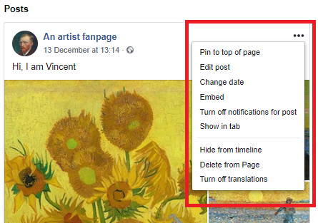
Source: own work
Sometimes instead of immediate publication, we prefer to schedule it or even create a post with an earlier date. To do this, when creating the content, click on the "Publish" button drop down list. There we will find options to:
- Schedule - allows you to automatically publish at a time of your choice in the future;
- Backdate - allows you to change the date of publication of the post to one earlier than the real one. Note - you cannot choose a date that would be earlier than the date the fanpage was created;
- Save draft - save the post in a draft version, allowing its subsequent completion and publication/scheduling.

Figure 25. Scheduling, changing dates, post draft
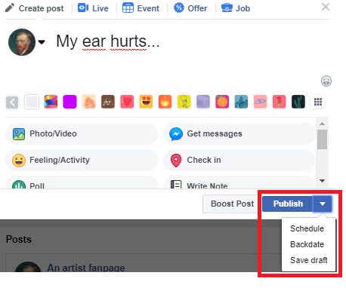
Source: own work
Although the time of creating a post is, for example, 15/12/2018, we can schedule it for later, indicating any day and time of our choice for publication of the post in the future. Then we choose from the calendar, for example, December 31, 2018 and we give the time, e.g. 15:30. It should be remembered that the nearest time moment when you can schedule a post is 10 minutes from any given moment, and the latest one - 6 months in advance.
Figure 26. Post scheduling
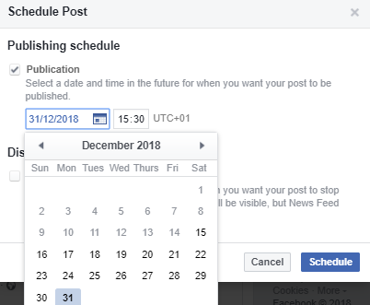
Source: own work
In this place there is also a second, less popular, option - "Distribution schedule". This allows you to specify the maximum time that the post should be displayed to your recipients. This is useful if you want to limit such distribution time, when your post will have a "short expiry date" - that is, at a given moment its value for the social media user will drop or the post will become out of date. A good example of such a post would be a quick competition - we schedule to publish it at 18:00 and end it at 21:00 on a given day. In this case we can use the "Distribution schedule" option and set it at 21:00. Thanks to this, no user will receive in their news feed (that is, the place for displaying our friends' activities and the posts we liked; the main, central board visible after the account has been registered) information about the competition at a time when it will have been decided.
Let us set the end of distribution of our post on December 31, 2018 at 18:30.
Figure 27. Distribution schedule
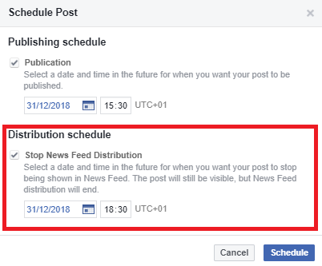
Source: own work
We will now test the "Backdate" option. We choose it and set the date at 13/12/2018 and we choose the option that this post will not be displayed in the newsfeeds of our fans.

Figure 28. Publication with an earlier date
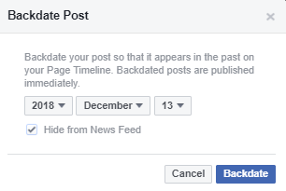
Source: own work
The final option is "Save draft". After clicking on it, our post is moved to drafts. To view all drafts, go to "Publishing tools" and then select "Drafts" from the left column.
Figure 29. Drafts
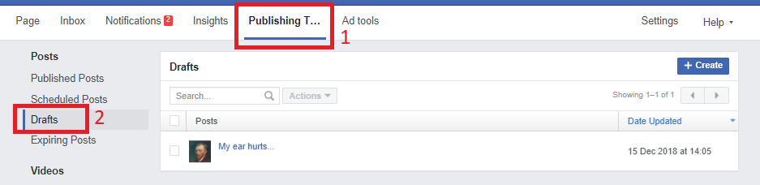
Source: own work
You can also go to drafts directly from the main page of the fanpage. If we have any pending drafts, then we will get a small message with a redirection.
Figure 30. Redirecting to drafts
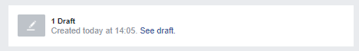
Source: own work

Exercise:
Prepare 3 posts using various options for posting visual materials:
- Upload photos/video - pin to the top of the page;
- Create Photo Album – schedule its publication;
- Create slideshow - publish immediately.
Remember that every post should be accompanied by a text commentary. After completing the task, you can delete the posts (optional).

- Facebook algorithm
To start with, let's take a look at the infographic showing statistics on content published on Facebook.
Figure 31. The number of activities on Facebook for all users during 20 minutes
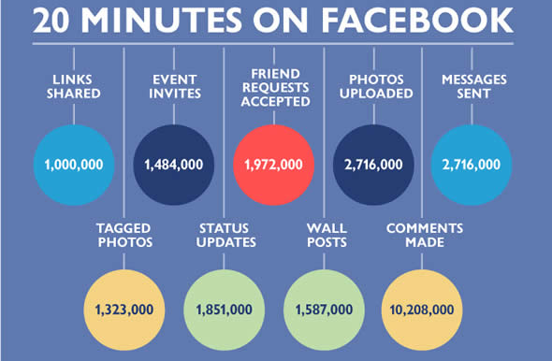
Source: http://www.seobrands.com/facebook-infographic-mania/
These statistics are impressive - after all, this is a real flood of information. However, not all of it reaches us, including even content in our language created by our friends. So how does the selection of what is actually shown on our News Feed take place?
It is a Facebook algorithm called Edge Rank that is responsible for this selection of posts. It is a complex system that takes into account many variables on the basis of which it calculates which posts to show which users. The algorithm is constantly being improved and its requirements are variable, but it seeks to maximize the effectiveness in displaying the information that is most interesting to given users. The system is based on the analysis of activities that may indicate that for a given person specific content of the selected fanpage may be attractive. If a given user often likes the posts of a selected page, for the algorithm this means that the topic discussed by a given person is interesting. This is obviously a great simplification, and there are many similar factors.
For all those creating content on Facebook, 3 factors are the most important, as illustrated in Figure 32.
Figure 32. The EdgeRank algorithm
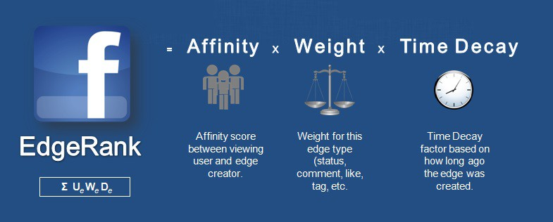
Source: https://fuelonline.com/social-media/facebook-marketing/facebook-edgerank-algorithm/
As we can see, the three most important factors affecting the visibility of a post are Affinity, Weight and Time Decay. Let us now introduce each of these factors.
Affinity - an indicator describing our relationship with the publishing entity. Among others, it defines how often we gave a like under the posts of the site, how often we shared the posts, and whether we were hiding posts from this site. So if you are not an active fan of a given fanpage, the algorithm will think that it apparently does not interest you because you do not want to interact with it. In this situation, the page disappears from the newsfeed and is replaced by those whose posts you like. To refresh a relationship with a given fanpage, just go to it, like a few posts or comment on it.
Weight - the weight of the post also has several components. The first of these is the type of content we publish - video uploaded directly on Facebook is "scored" much better is than regular text. This is why in Chapter 5 we said that it is not recommended to publish posts that do not have any illustrations.
The Weight of content types from the largest to smallest is:
- Video (also due to competition from YouTube).
- Live broadcasts (also due to competition with Periscope).
- GIFs (simple, short and looped animation).
- Photos.
- Links.
- External videos (e.g. YouTube).
- Text.
The second factor that influences the importance of a post is the engagement it generates among users. If it receives 20 shares, 40 comments and 100 reactions within 5 minutes, then for the algorithm this means (and rightly so) that it is much more interesting content than a post that gained only 5 likes in an hour. What is important - the algorithm also assesses whether people who have responded to our publications themselves have an extensive network of relationships (one could talk about the importance of users). Here, however, you can still get "negative points" if our post evokes negative emotions among users who decide to hide it.
Weight of activity under the post from the biggest to the smallest:
- Sharing.
- Comments.
- Reactions.
- Likes.
- Clicks (e.g., a link or photo in the gallery).
That is why it is so important to have constant contact with our profile, for example by responding to all comments - this is not only good manners for creating positive relationships, but an important factor in calculating the importance of a post.
Time Decay – this is just the topicality of a given post. Time works to the disadvantage of our content, which is why it is so important that the post immediately evokes reactions. If after a few hours nothing happens, we can probably write off our material as wasted.
Knowing the principle of the EdgeRank algorithm (which determines what will be displayed to a given person) it is easy to understand why so many site administrators are so keen on getting posts liked. Often, this procedure even takes unethical forms when it is a requirement to like a competition post (which is prohibited in Facebook regulations - we will discuss more about competitions later in the guide). Edge Rank, moreover, deals better with such inappropriate practices (clickbaiting, or deliberately misleading users in order to increase click-throughs in given content or extorting likes), by lowering their reaches. In fact, the point is not to invite reactions to users in an intrusive way, but to create such content that will simply be attractive for them. As Bill Gates remarked in 1996: content is king.
Figure 33. Content is king
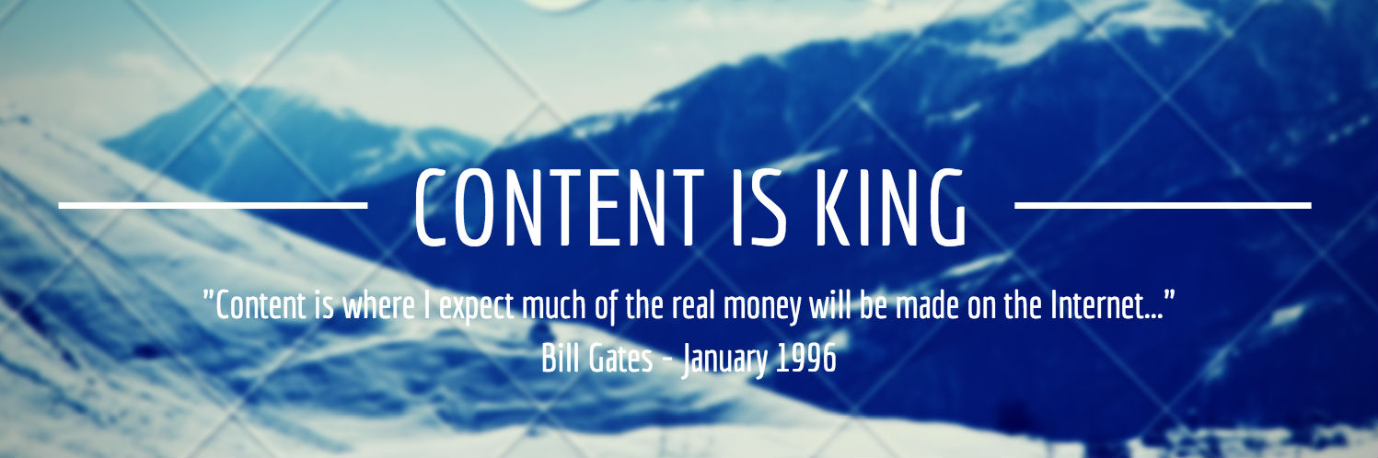
Source: https://www.craigbailey.net/content-is-king-by-bill-gates/

Exercise:
Imagine two fanpages - one of them has 5,000 likes, but most of them were collected using the unethical method of so-called "Buying likes" - so they are often liked by fictitious or inactive accounts. The second one gathered 500 faithful and committed fans. Consider:
- The posts of which of the fanpages are more engaging? Oral
- What strategy should the administrator of the fanpage with 5,000 likes adopt? Oral

- How to create engaging content
As we mentioned in the previous chapter, content rules the Internet and social media. Attractive content of a fanpage is the key to the heart of the fans. This is the most natural, therefore effective, way of establishing relationships with social media users, which is why it is so effective. In order to reach recipients even better, it is worth remembering that winning people over is a multi-stage process.

Figure 34. The process of creating a relationship with the recipient
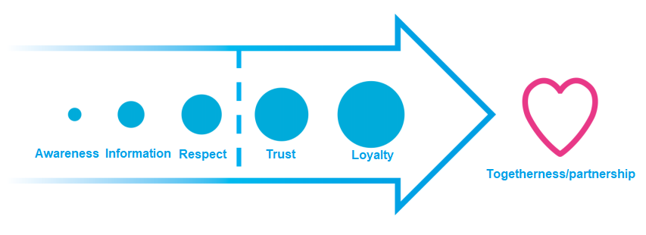
Source: Advanced Brand Management.
This process is a path that everyone goes through. The first stage is the presence of the recipient in consciousness; therefore it is necessary to repeat the message and display the logo. The second stage is more detailed information and education about the company. The third is building respect through the transmission of valuable content. The further stages are deepening the relationship when the recipient becomes a customer and makes a purchase - if he is satisfied with our offer, on which he spent money, his trust will turn into loyalty. In the final phase, our recipient even becomes our unofficial ambassador.

Figure 35. Basic questions of the fanpage communication strategy

Source: own work
If you want to create more engaging posts, it's worth remembering a few tricks:
- Voting response - create a graphic with several options to which reactions will be assigned. Ask your audience to vote on a subject (see Figure 36).
- Ask questions - raise a discussion topic. Maybe an artist raises controversy? Has there been a widely commented event in the cultural industry? Ask what your recipients think about all this. Ask closed questions that you can answer yes or no, because the recipients will often treat liking the post as a positive answer.
- Real Time Marketing - the ability to respond to current events will be useful here. A topical voice in a current case often attracts the attention of many recipients.
- Background content - people love unofficial information that is hidden under the mantle of professionalism. Tell your fans what a day in the life of a creator of cultural heritage is like!
- Tagging - if the post is or may be of particular interest to a specific person (e.g. he is in a group photograph), it is worth tagging it (simply enter '@' and the username, see Figure 37). However, it is better not to abuse this option, because it can make our recipients angry.
- Polls - a good way to engage fans. There are only two options to choose from in polls, so you should ask closed questions. To create a poll, start writing a post and select "Poll" from the box (see Figure 38).
Figure 36. Voting with reactions
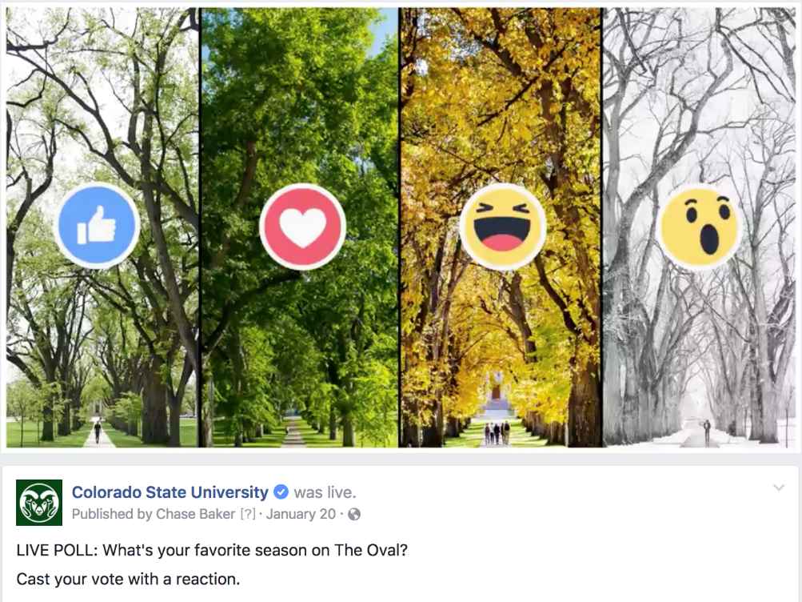
Source: http://social.colostate.edu
Figure 37. Tagging a profile
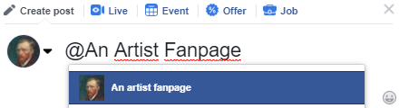
Source: own work
Figure 38. Creating a poll
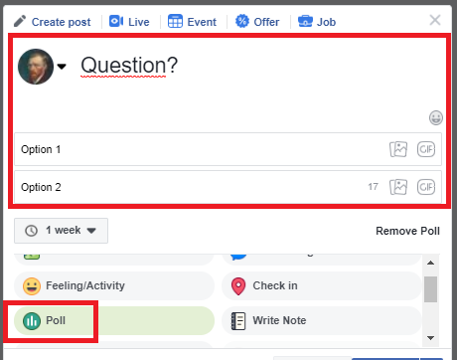
Source: own work
At this point, it is worth mentioning one more important issue - building a community of people. In addition to engaging people in our content, we should strive for them to stay with us for longer, that is, to like our fanpage. To this end, active user acquisition must be used, which amounts to sending invitations to people who responded to our post. Research shows that the sooner we invite a person who has liked our post, the more she will be willing to accept the invitation.
Figure 39. Active acquisition of users
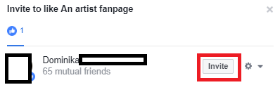

Source: own work
Competitions on the social networking site Facebook are a great tool for promoting a page and acquiring new fans. However, several principles should be followed when organizing this type of profile activity. We present the principles that should be followed below.

Figure 40. Principles for organizing competitions on Facebook

Source: work based on the UMW report
As can be seen from the posted requirements, many competitions on Facebook do not meet all the criteria. They are punished for breaking them, first of all a with temporary ban (blocking the use of the account) for the profile. The most frequently violated rule is that of not enforcing tagging, fanpages and sharing. It can be got around to a certain extent - instead of setting these actions as a condition of participating in the competition, it's enough to gently encourage users to take them. Some of them will do it out of habit.
When organizing a competition, one should also remember several good practices. The competition task should be primarily:
- not too difficult, but adequate to the reward offered;
- creative and interesting;
- related to the area of culture in which we operate, our team, institution or co-creators.
Exercise (30 min.):
Prepare a Facebook communication strategy for your company:
- Specify the frequency of publishing entries. Written
- Prepare a narrative line consisting of 5 areas. Written
- Specify what type of content will dominate (videos, photos, texts?). Written

- How to finish
There is also one more important option available to users - removal of the fanpage. To find it, go to "Settings", select the "General" tab in the left column and then go to the very bottom of the page. There you will find the option "Remove page", which allows you to delete the profile. WARNING! This operation is irreversible!
Figure 41. Removing fanpage
Source: own work
- Instagram - creating an account
Let's finally go to Instagram. To create an account on this portal, go to www.instagram.com. This process is maximally simplified and can be completed in a few steps. At the very beginning we have to fill in a few fields, including: phone number or e-mail address, account name, username and password. After entering the data, click "Next".
Figure 42. Registration on the Instagram portal
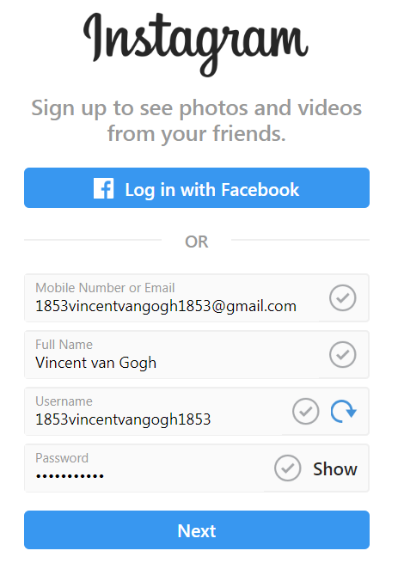
Source: own work
In the next step, we answer a question about age by selecting one of two options: under 18 and 18 and above.
Figure 43. Selecting age bracket on the Instagram portal
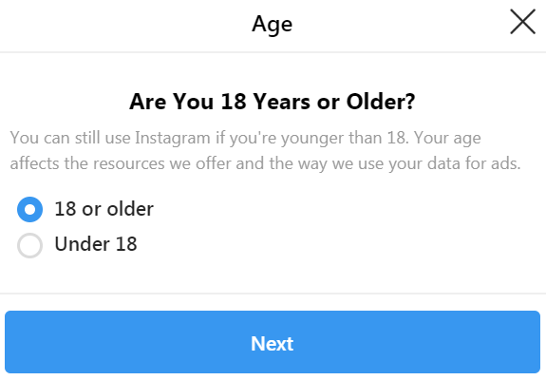
Source: own work
Congratulations! You have just created an Instagram account. Now let's move on to a discussion of the activities and principles that will help you use the full potential of this social medium.

- How to successfully run an Instagram account
At the beginning, we must remind you that Instagram is dedicated primarily to mobile devices, to the extent that it is not possible to use it, for example, from a laptop, because we will not be able to publish content. This is only a superficial limitation, which, however, seems to be the deciding factor in the success of this social platform - once we get used to it and regularly post our videos and photos on Instagram, it will prove not only easy, but intuitive, natural and spontaneous.
However, in order to achieve better results from our activities undertaken on this social network, several principles should be kept in mind. They will help us reach a wider audience, build awareness and create lasting relationships with people who follow our profile.
Figure 44. Principles for effectively running an Instagram profile

Source: own work based on http://blog.bloomboard.co/2018/04/26/poznaj-33-sprawdzone-metody-jak-zdobyc-nowych-followersow-na-instagramie/
However, following these principles is not everything. In addition, we should beware of actions that may undermine our efforts. Only running the profile in accordance with the best practices and avoiding errors will allow us to fully use the promotional potential of our work.
Figure 45. Typical Instagram users’ errors

Source: own work based on https://sprawnymarketing.pl/instagram-marketing-bledy/
Instagram is today an extremely effective communication and promotion tool. It should not be underestimated because its importance is constantly growing. Due to its specific nature, it is able to reach recipients more effectively than other social networking sites and create constant engagement in the activities undertaken. It should be seen as the next most important channel for communication with recipients, immediately after Facebook, for every creator of intangible culture.

- LinkedIn - creating an account
Creating an account on LinkedIn is a multi-stage process. To start it, just go to the main page of the portal and fill in the window by entering your name, surname, e-mail address and password. After entering the necessary data, you can click the "Join Now" button.

Figure 46. Creating an account on the LinkedIn portal
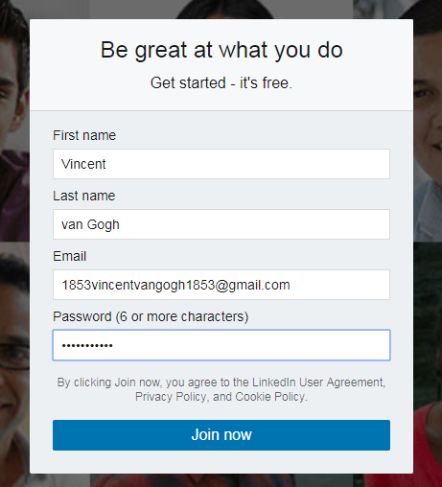
Source: own work
The next step is to choose our country of origin and, sometimes, enter the post code. We complete the actual country from the drop-down list and go to the next step in creating the profile.
Figure 47. Selecting the country of origin
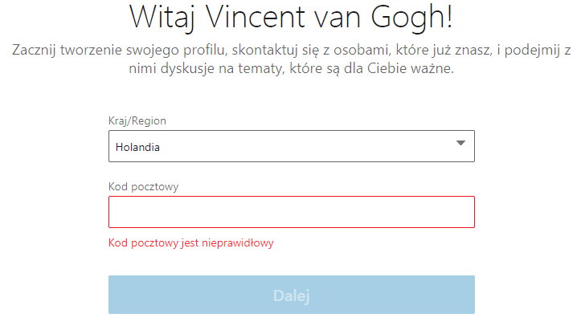
Source: own work
The next three sections to be completed are closely related to our professional activity. The portal wants to learn three things from us: what position we currently occupy, where we work at the moment and in what field. In the first two cases, we enter the information ourselves, while the field is selected from a drop-down list. If we are studying, we can check this option, which is located above the "Continue" button.
Figure 48. Information on our professional situation
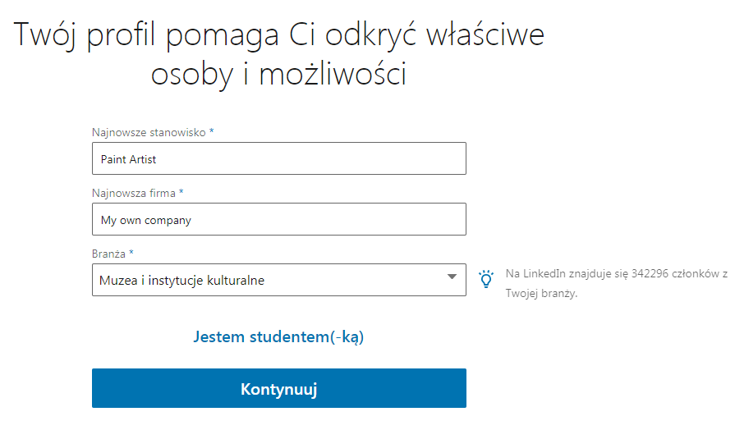
Source: own work
The next step is account verification. We go to the email account that we provided in the first step of the entire process and copy the 6-digit code. If we have not received the message, we can ask the system to generate it again. After completing the field, we go further.

Figure 49. Account verification
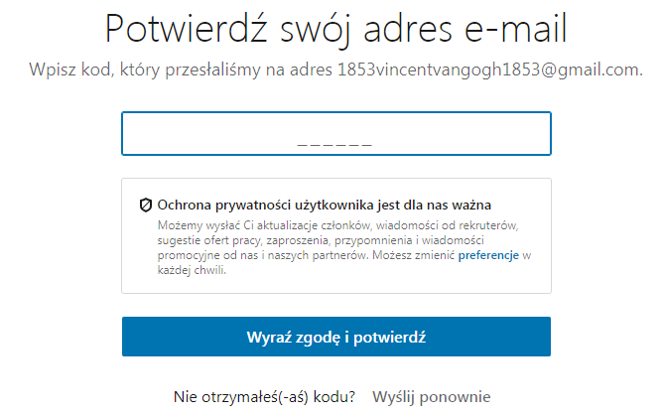
Source: own work
The final stage (which you can skip, although it is better not to) is importing contacts from our mailbox. After agreeing to this, the system automatically downloads all the necessary data for it. Thanks to this, from the very beginning we will have a basic network of contacts.
Figure 50. Import contacts
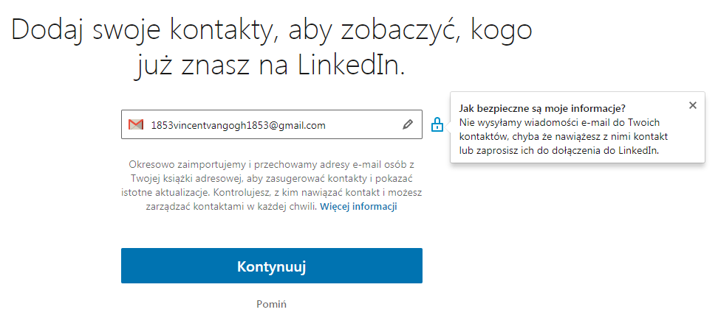
Source: own work
After pressing the "Continue" button, we can start working on our personal account. With its help, we will represent ourselves, but it is worth remembering that such a profile does not have the status of a private account as it does on Facebook. On LinkedIn, each profile is official and should have a professional character.
Such an account, however, allows you to build up a contact network and the image of an individual person. There is also a possibility - if you already have a personal account - to add an institution account. To do this, click on the icon in the upper right corner, and then on the right side select the "Create a Company Page" option.
Figure 51. Create a Company Page
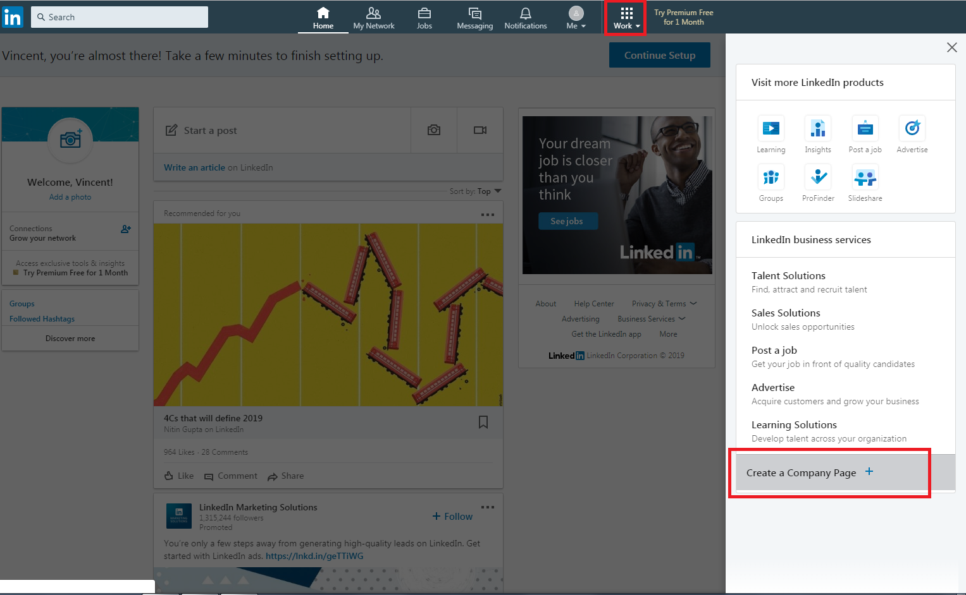
Source: own work
A window will appear with a selection of 4 types of entities that we can represent. They are: "Small business" - fewer than 200 employees, "Medium to large business" - more than 200 employees, "Showcase page" - a sub-page associated with an existing page, "Educational institution" - schools and universities. We choose the actual type and go on to the next step.
Figure 52. Selection of the type of entity
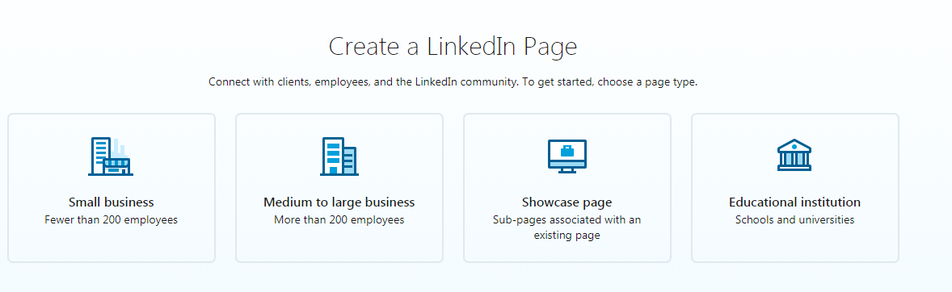
Source: own work
The final step towards creating a company page is ahead of us. Here we give the name of the profile created (preferably the name of the entity we represent), we create a friendly hyperlink and provide details about our company/brand/institution.
Figure 53. Details about the business page
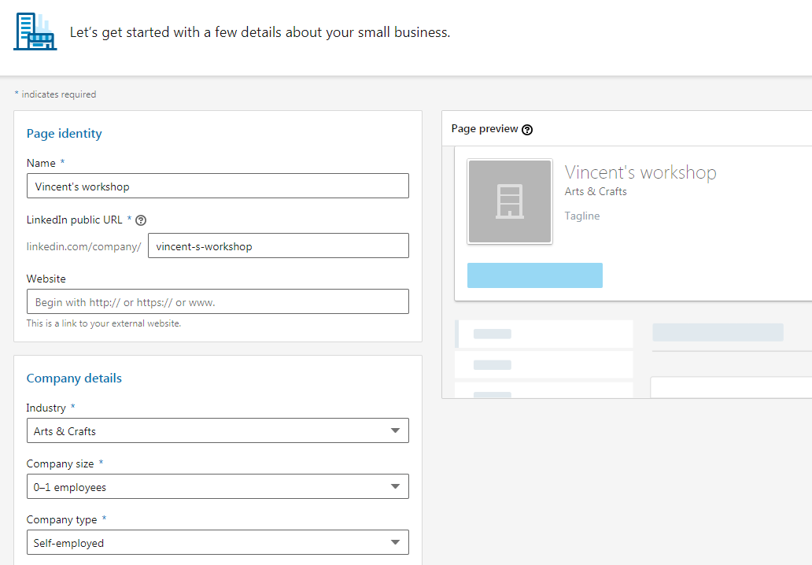
Source: own work
While still on this subpage, we can add the logo of the entity we represent and describe it in the header. Although both of these activities are optional, we should certainly conduct them as they will make our communication on LinkedIn more effective.

Figure 54. Adding a logo and header to a company page on the LinkedIn portal
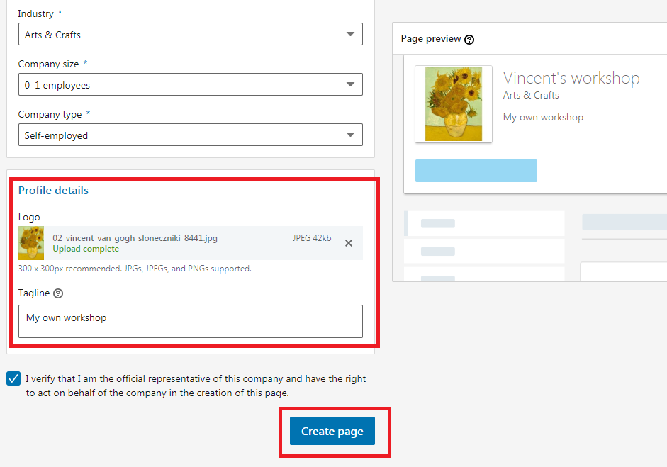
Source: own work
Well done! You have just created a personal account and a company account on LinkedIn! Now let's get into action and think about what you can do to be able to run both of these profiles most effectively.

- How to successfully run a LinkedIn account
LinkedIn is a social medium that should be used to achieve specific business and professional goals. It allows you to create an image as an expert and to establish interesting contacts that can allow the implementation of ever more spectacular projects. Nothing, however, comes without effort, and you should also try to make sure that the results are as good as possible. For this, it will help to run the profile on the basis of a few key principles.

Figure 55. Principles of effective operation of a profile on the LinkedIn portal

Source: http://czaplicka.eu/7-rad-skutecznie-wykorzystac-profil-LinkedIn/
Remembering and following these principles will allow us to optimize communication. However, in order to take full advantage of the possibilities available on LinkedIn, we must additionally take care to avoid the typical errors that users of this social media often make.

Figure 56. Typical errors of LinkedIn portal users

Source: https://businessinsider.com.pl/rozwoj-osobisty/kariera/czego-nie-robic-na-portalu-LinkedIn-jakich-bledow-unikac/lqe0zhc
An appropriately managed profile on LinkedIn - following the principles discussed and avoiding errors - will allow you to achieve goals that are difficult to reach through other portals. So if we want to enter the world of big business with our creative activity, it is necessary to take good care of our profile on this social platform.
Social media these days is one of the most effective channels for reaching a wide audience. However, although in principle each of us may use them on a daily basis, we should be aware that running a private account has little to do with communication via an official or company account. We have to create very engaging content, set a strategy and schedule of activities, select the appropriate channels (because Facebook is not the be-all and end-all of social media) and learn the activity of algorithms and the nuances of portals. Only then will we be able to create posts that will be of interest not only to our friends, but also to people who are completely new to us, who have simply become interested in the content published by us.

- Further information
- Analytics
Facebook statistics allow for a more conscious running of a fanpage and planning of paid promotions. They are a huge treasury of knowledge that, if used well, will help us to gain a greater reach and optimize the activities we undertake. Let's look at the most important possibility of the basic tool for tracking statistics offered by Facebook. To use it, simply select the "Insights" tab from the upper menu of the profile.
In the "Likes" section, we can check the data about the page's likes. They allow you to check what actions triggered an increase in likes, which posts did not appeal to fans. It is worth monitoring these data and drawing conclusions from them on an ongoing basis.
"At the very top we find a slider, with the help of which we can change the range of dates for which we want to see data (this can also be done using the calendar in which we set the beginning and the end). After setting the appropriate range, we can trace in the graph the total numbers of fans day by day".
Figure 57. Total number of page likes
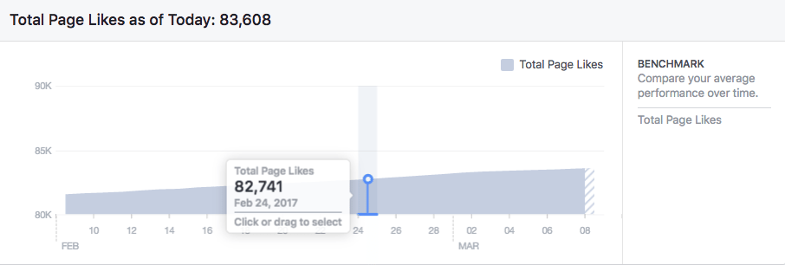
Source: https://buffer.com/library/facebook-insights
Below is the net number of likes (total number of likes - number of withdrawn likes) in a given time interval. On the right side there are options that allow you to view:
- a graph presenting only the number of withdrawals of likes,
- a graph presenting only the number of organic likes (i.e. from sources other than paid),
- a graph presenting the number of paid-only likes (gained thanks to advertisements).
Figure 58. Page likes graph
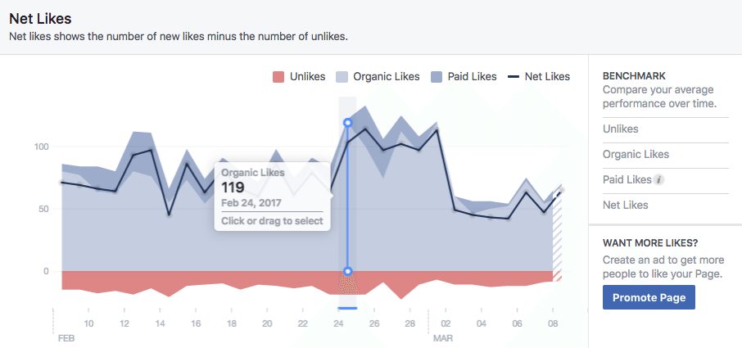
Source: https://buffer.com/library/facebook-insights
The next chart presents the sources of our fanpage likes. There are five places from which users can click "Like", so that they become people who follow our page. These are:
- likes directly on the page;
- likes from the level of suggestions offered by Facebook;
- likes after seeing a post published by the page;
- likes from mobile devices (phones and tablets);
- likes from other sources.
Figure 59. Graph showing on which devices users liked our page
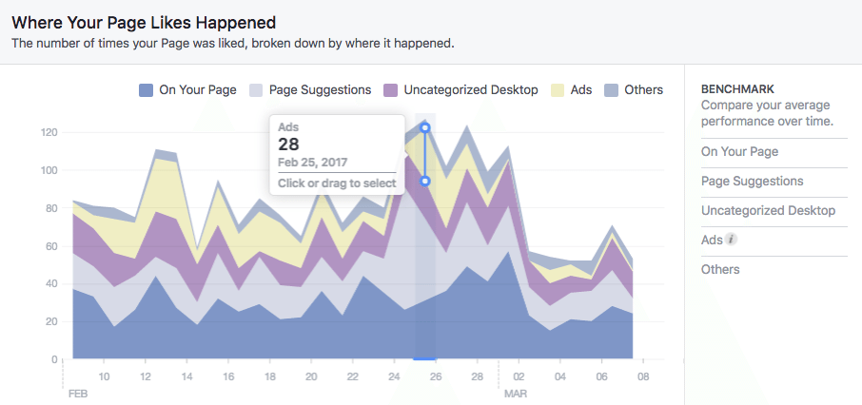
Source: https://buffer.com/library/facebook-insights
Thanks to the "Reach" tab, we can see how many unique users have reached our post. Reach is a more interesting statistic for us than views. Reach determines the number of users who viewed the publication, while views tell you how many times it was displayed. If two users viewed our content 4 times, the range is 2, and the views are 8.
The chart in the "Reach" tab shows us the reach divided into organic (the content was displayed to users free of charge, as a result of the Edge Rank algorithm) and paid (the content was displayed to users thanks to being sponsored). We can also check on the timeline in what period our statistics were the best.

Figure 60. Post reach
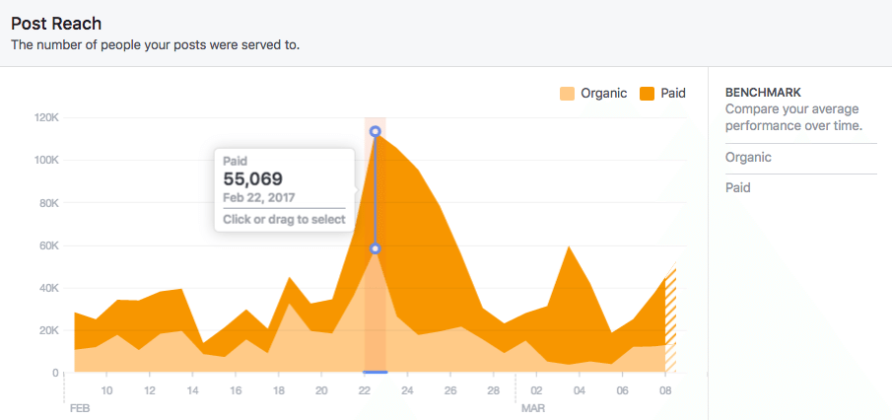
Source: https://buffer.com/library/facebook-insights
The next chart provides information on the number (in a given period) of:
- Shares;
- Comments;
- Reactions.
This graph will help us determine what user activities give our page the greatest reach and on what days the activity of the audience was the most intense.
Figure 61. Number of shares, comments and reactions
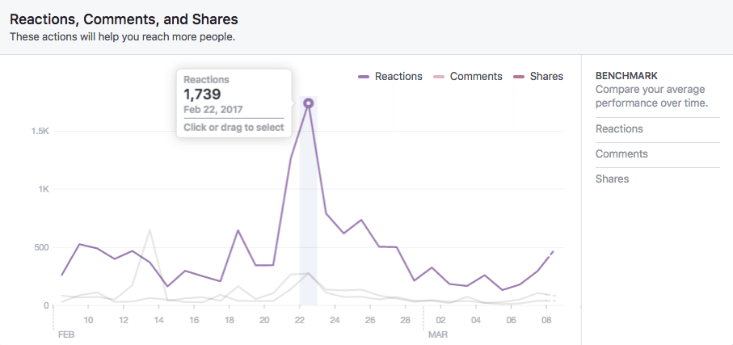
Source: https://buffer.com/library/facebook-insights
While the previous graph showed actions that are positive for our fanpage, the next one shows the negative reactions. From the graph you can find out how many people:
- hid a particular post;
- marked the option "hide all posts from the page";
- reported a post as spam;
- withdrew their like for the page.
Figure 62. Graph showing the negative reactions of users
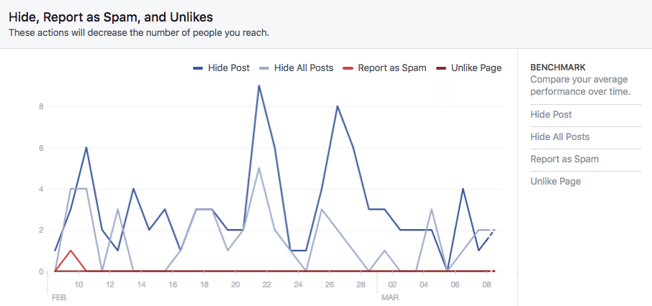
Source: https://buffer.com/library/facebook-insights
This chart will help us determine what unwanted actions users most often take on our page. The timeline will also help determine when this occurs, and through this information we can find out which posts have caused the most negative reactions.
In the final graph, however, we can see the total reach, i.e. the number of people who have seen any content related to our page. In the graph options, you can choose to display only the organic reach or only the paid reach.

Figure 63. Total reach
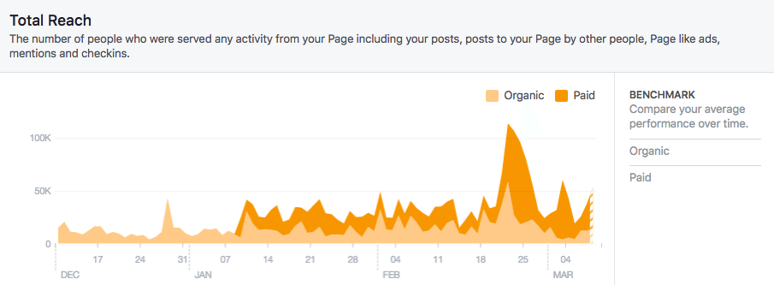
Source: https://buffer.com/library/facebook-insights
In the "People" tab we can get information about groups of people who have been in contact with our page. These groups are:
- People who liked the fanpage;
- People who have followed the fanpage;
- People who we have reached with the content of our fanpage;
- People who have reacted to the content published by the fanpage;
We can receive the following demographic data about these groups:
- Age;
- Gender;
- Location in the world from which the connection was made to our page.
All this information, wisely analyzed, will be a valuable hint regarding the development of our profile and the way of selecting target groups for paid promotional activities.

Figure 64. Demographic data of fanpage recipients
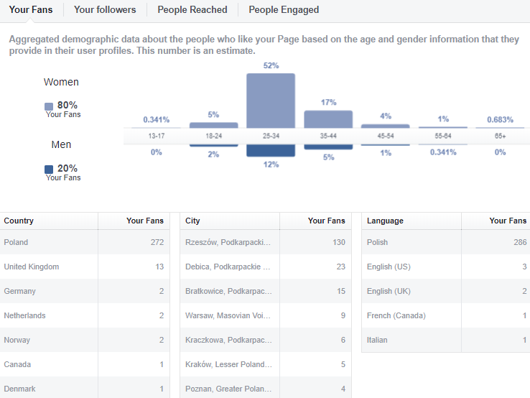
Source: own work
To get even more information, just go to the "Summary" tab and click the "Export data" button in the upper right corner. When exporting, specify the period to which the data should apply. Thanks to this operation, we receive detailed information about our fanpage and the content published on it.

Figure 65. Export of data to an Excel file
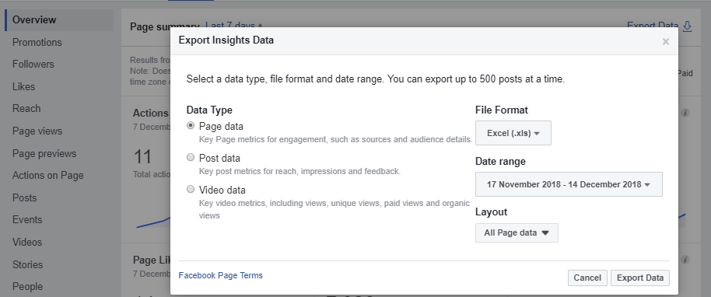
Source: own work
All of the data will be exported to an Excel file. Although this form of data presentation is not the most aesthetic, affordable or transparent, it allows you to perform many different operations using the Excel program formulas and to sort the data according to your needs.
In the next "Posts" tab, we can see detailed data about the content we publish:
- Post type;
- The group of recipients;
- Reach (the number of people who saw the post) - after hovering over the post we get more detailed information broken down into paid and organic reach.
Figure 66. Post statistics
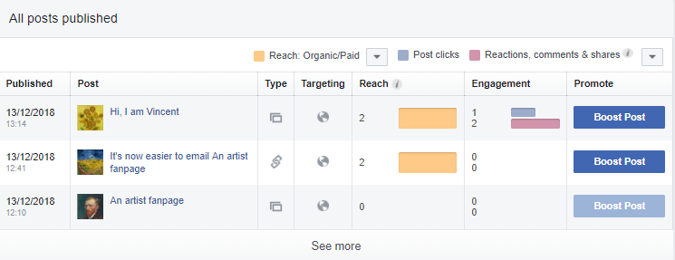
Source: own work
There are also additional tools that allow us to get even more statistics and information about our recipients (not only in social media) - they are primarily Facebook Pixel and Facebook Analytics.
The first of these tools is a special html code that should be placed on our page. Properly configured, Facebook Pixel allows us to get much more compiled data that can be useful for optimizing our advertising, remarketing campaigns (targeted at those who have already visited our page) or precise defining of target groups.
Facebook Analytics, on the other hand, includes many additional tools, the most interesting of which are:
- Funnels - allow you to track the way people visit. Thanks to this, it is possible, among others, to indicate the stage at which users leave the page. Analysis of the information acquired through funnels allows you to optimize the page.
- Cohorts - provide information on groups of users who have taken the same action. Thanks to this, you can analyze, for example, data about users who added a product to an electronic cart on the page.
- Segments - provide information on user groups based on the type of events, demographics, device information and other non-standard features. They allow users to be analyzed on the basis of their activities on the page and their demographic data, which can be used to define target groups for advertising campaigns on the portal.
- Retention - an indicator of the percentage of recipients who return to our page after a certain time.

- Paid promotion
Although Facebook users could run their fanpage for many years without investing in paid promotion, nowadays it is very difficult. While it is still not impossible, it requires a lot of time and creation of a lot of engaging content. Currently, the organic reach of posts we publish is only about 6%! This means that our post without advertisement support (and if the post is not a very effective viral) will reach only 6% of people who like our fanpage.

Figure 67. Average organic reach and paid reach of posts
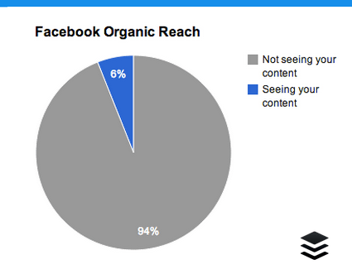
Source: https://leadsdubai.com/facebook-organic-reach/
The trend of reducing the average organic reach is consistent and visible for several years and it is not likely to change. It is likely that the situation will slowly stabilize and the rate of reduction in reach will be smaller or will stop at a certain level, but it must be clearly stated that the best times of organic reach are already behind us.
Figure 68. Is organic reach dead?
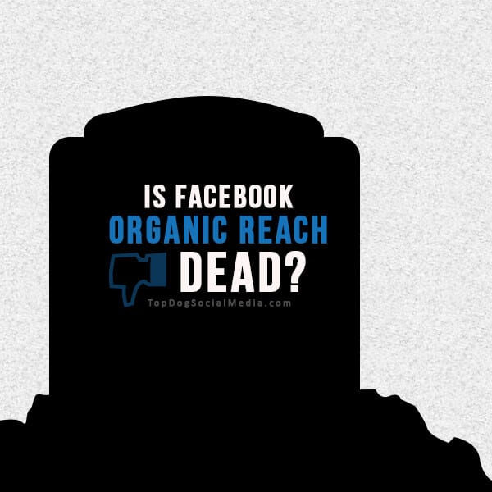
Source: https://topdogsocialmedia.com/facebook-organic-reach-dead/
It is not true that the organic reach is completely dead. We are still theoretically able to reach recipients without spending money, but it would require regular creation of such posts that would gain dozens of shares, hundreds of comments and thousands of reactions. Of course, sometimes this happens when our post spreads on a viral basis, but the mass creation of such content is an extremely difficult task.
Figure 69. Viral marketing is not easy to achieve
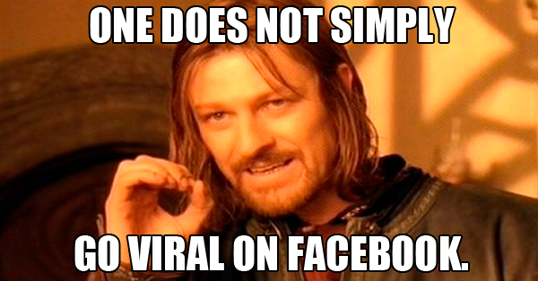
Source: https://www.postplanner.com/most-viral-memes-posted-on-facebook/
So if we rely on really large reaches in a relatively short time and without an inhumanly difficult task, it will be necessary to invest a certain amount of money. Fortunately, advertising on Facebook is still a relatively cheap solution, and with the ability to precisely determine the target group it can also be very effective. NOTE: in the absence of interesting posts, even the most expensive promotion will not help us!
Let's move on to the panel that allows us to prepare our first ad. In the upper panel of the fanpage, go to the "Ad tools" tab and select "Overview" from the left column. If we have not yet carried out any promotional activities, we will see in the window information on what data we can get when our first campaign ends:
- Reach;
- Engagement in posts;
- Clicks on the link.
To create our first ad, click on the "Create Ad" option.

Figure 70. Ad creation panel
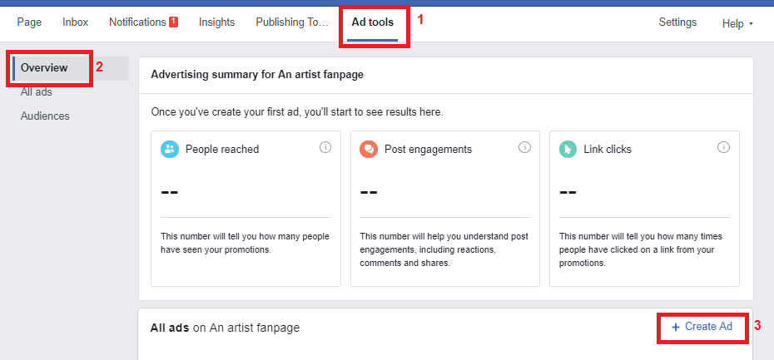
Source: own work
A window will appear, from which we will be able to choose one of 4 types of ads that serve to achieve different effects:
- Boost a post - this is used to promote a particular post we have chosen. It's best to use this option if we release specific content that we would like to reach as widely as possible. This may be, for example, a competition post or information about the premiere of a new album;
- Promote your Page – this is used to promote our fanpage. It allows us to get additional likes of our profile, and thus long-term creation of a community around our activity;
- Get more website visitors - this is used to promote our external site, e.g. a blog;
- Get more leads - this is used to acquire contacts for business development and sales.
The basic and most important forms of advertising are the first two of these types.
Figure 71. Types of ads on Facebook
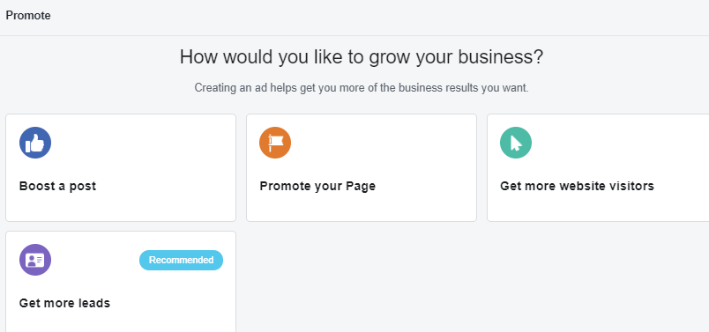
Source: own work
To begin with, we'll start with "Boost a post" ads. We choose it and a window appears with the choice of the post we want to promote. We chose our post with a miniature of sunflowers.
Figure 72. Choosing a post to boost
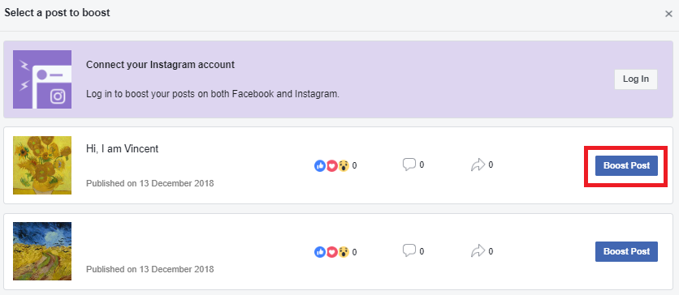
Source: own work
A panel will appear in which we will set up a detailed campaign. We will start by defining the target group. To do this, click the "Create new audience" button.
Figure 73. Advertising campaign panel
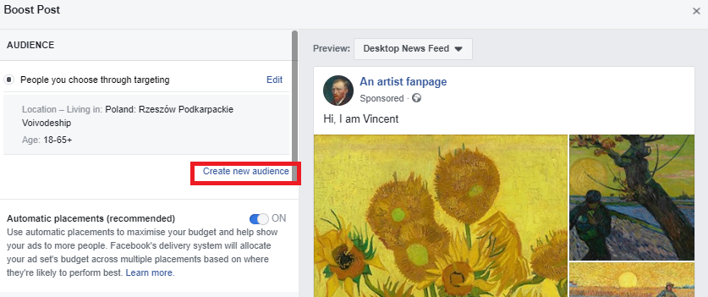
Source: own work
A window will appear in which we can define our target group in terms of:
- Age – we choose the lower and upper age limits from the drop-down list.
- Sex - we choose the sex by means of a button (can be both).
- Location – we enter in the "Ad location" field.

Figure 74. Specifying the target group
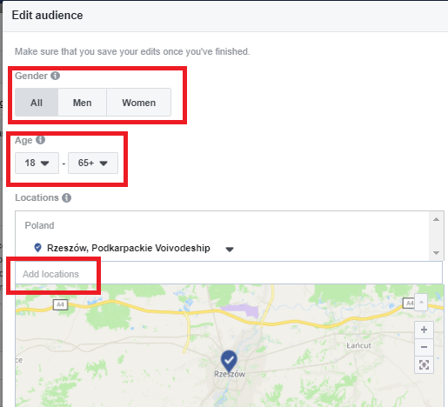
Source: own work
Locations are best selected from the drop-down list, which will appear after entering the first few letters of the name of the town/city that interests us.
Figure 75. Selecting a location
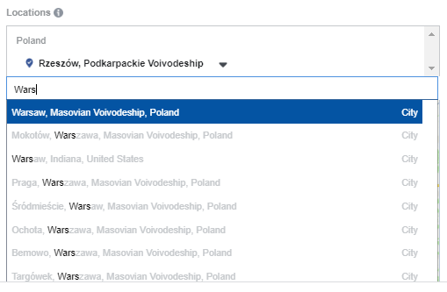
Source: own work
Let us stay for a while longer at the location, because it can be specified even more precisely. After choosing a place, we can also determine if we want the advertisement to reach only this city, or also to other smaller towns within a given radius. We chose the second option and set the radius to 22 miles. Additional locations can be added by repeating the entire procedure, starting from entering in the "Add location" field the name of the city we are interested in.
Figure 76. Location - specifying the radius
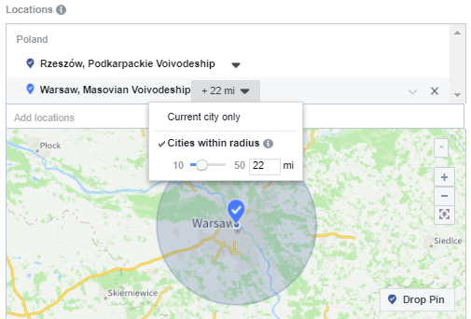
Source: own work
The next step is to determine the interests of our target group. For this purpose, we fill in the "Add demographics, interests and behaviours" field. We enter a few letters specifying the interest and choose from the drop-down list of suggestions or search among the ready categories. We should remember that Facebook will address the advertisement to people who have at least ONE of the features we have entered - this means that the more of them we enter the more we will expand our target group.
To slightly restrict the target group, we can also exclude people on the same principle. All we need to do is click on the "Exclude people" option below and we will see the same panel as for adding features and interests.
Figure 77. Adding features and interests to our target group
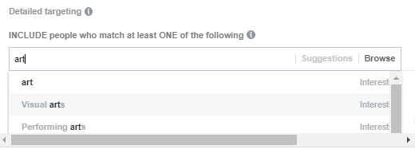
Source: own work
In the next step, we choose the amount we want to invest in the ad. We can choose it from the drop-down list or enter our own by selecting the "Choose your own" option. Next to the selected amount, Facebook gives the approximate value of the reach that we can achieve with the help of our advertising.
Figure 78. Selecting amount
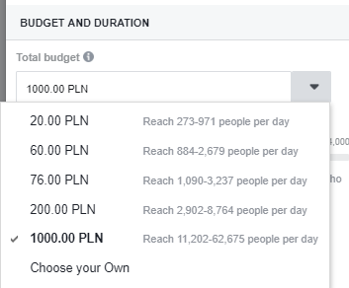
Source: own work
Next, we choose the duration of the promotion. We can use one of three available buttons:
- 1 day.
- 7 days.
- 14 days.
Or we can specify our ad's end date ourselves. We chose the last option and set the end date of the advertising campaign as December 27, 2018. Below Facebook immediately calculates what amount we will spend on advertising per day.

Figure 79. Specifying the duration of the ad
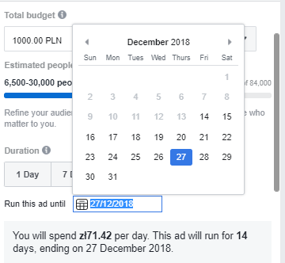
Source: own work
With the post promotion so prepared, we can start and enjoy the effects. However, let's discuss another type of advertisement - "Promote your Page". We return to the window with the choice of the type of advertisement, choose the second option and go on to specify its details. Here we select the ad format from the drop-down list:
- Single picture;
- Video;
- Slide show.
Figure 80. Selection of the advertisement format
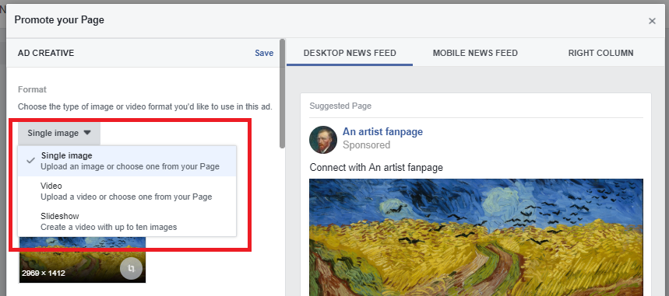
Source: own work
We choose the first option and continue to set up the ad. We must choose a photo. We can do this by uploading the file from our disk or using the database of free graphics. After selecting a graphic, we can easily crop it by clicking on the icon in the circle in the lower right corner of the image view.
Figure 81. Choosing a picture for the promotion
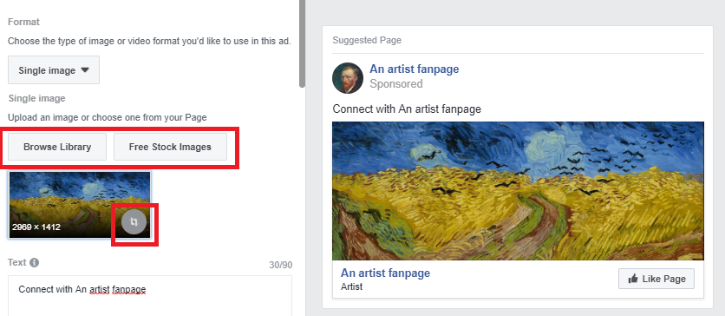
Source: own work
Cropping is done by moving one of the four points at the corners of the image. We can also click on the field of the displayed image and move it around the entire graphic area. On the right side we get a preview and information as to whether the selected fragment contains too much text.
Figure 82. Cropping the image
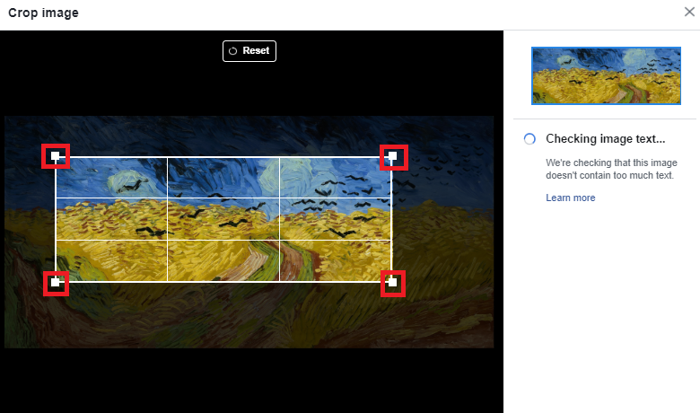
Source: own work
We can write our own text for our simple fanpage ad. It should encourage recipients to familiarize themselves with the page. The length of the text is limited to 90 characters with spaces. On the right side, a view of our advertisement is displayed along with the text.
Figure 83. Entering text into the advertisement
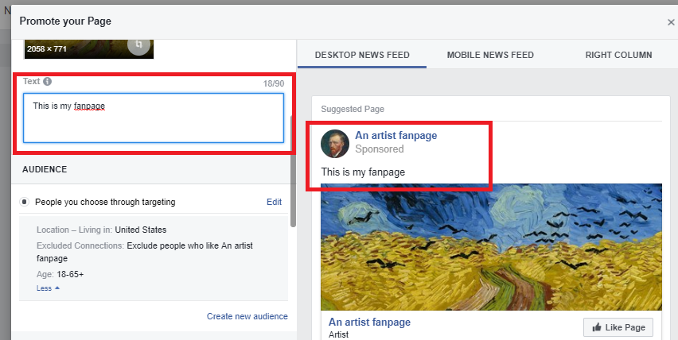
Source: own work
Then we set the target group, which is specified in the same way as in the previous type of advertisement. However, the budget issue is slightly different, where an additional option appears - "Run this ad continuously". This means that a fixed amount for the fanpage promotion will be paid on a continual basis. The advantage of this solution is that we do not have to constantly renew the promotion of our page, and constant financial support for it will result in the successful building of a community and an increase in likes for the fanpage. However, we have to remember about this solution in case we give up on running a profile because even then money will be collected from us.
When deciding on this option, it should be remembered that this time it is not the total budget (because due to the lack of a clear end date for the promotional campaign it is impossible to determine), but the daily budget. It is worth approaching this issue sensibly and choosing rather small amounts, which in the long run will bring us many benefits.

Figure 84. Continuous campaign budget
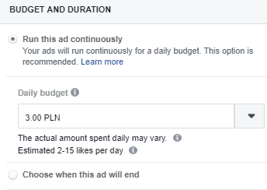
Source: own work
After configuring the final items, we can start with the promotion.
NOTE! Facebook limits the reach of ads with graphics containing too much text - sometimes it may also not allow the release of such an advertisement.

- Twitter - creating an account
Our adventure with Twitter - as with any social media - should start by creating an account. Go to the home page www.twitter.com and click on the "Sign Up" button.

Figure 85. Registration on the Twitter portal
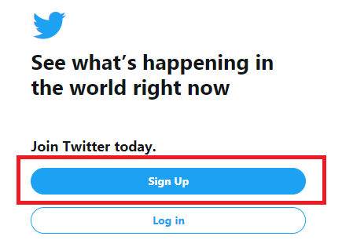
Source: own work
After clicking, we will see a window with two fields, in which we must enter the name of our account (by default, our first and last name or the name of the entity we represent) and e-mail address or phone number - the choice of verification method depends on us.
Figure 86. Name and email address for a Twitter account
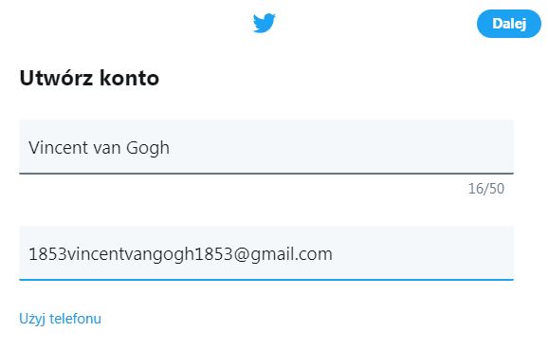
Source: own work
In the next stage, we configure some basic issues regarding the use of Twitter. We can agree on three issues: the ability to search for our profile via our email address, receive advice on the effective use of Twitter tools and on receiving ads. As can be seen in Figure 155, we consented only to the first two options and we did not agree to receive advertisements.
Figure 87. Initial account configuration on Twitter
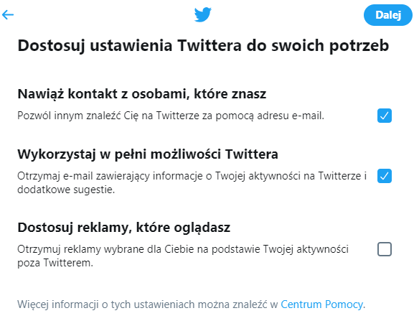
Source: own work
The next step is formal confirmation of the willingness to register an account. This means acceptance of the Portal's Privacy Policy, Terms of Use and use of cookies and confirmation of age (over 13 years).
Figure 88. Confirmation of registration
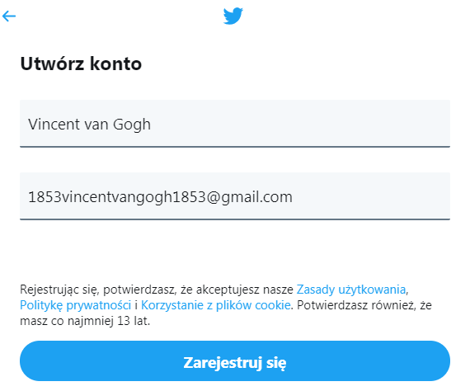
Source: own work
Next, we need to verify our account. The site asks us to provide a verification code which was sent to the e-mail address we provided during registration. If nothing has arrived, we can ask the system to generate another code. Once we receive it, we copy it and fill in the field.
Figure 89. Verification of the Twitter account
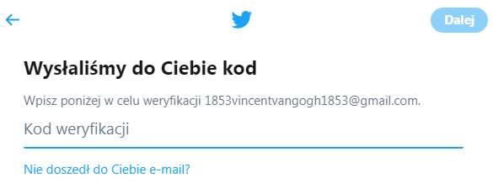
Source: own work
The next step is to enter a password that will protect our profile. The requirement for Twitter is a password of at least 6 characters, but to ensure greater security, it is worth making it more complicated, using small and capital letters as well as special characters and numbers.
Figure 90. Create a password for your Twitter account
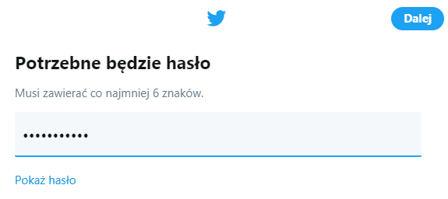
Source: own work
We finally get to the moment when we start personalizing our account. In this step, we can choose a profile picture by clicking on the large icon highlighted on the screen in the red frame. This stage can be omitted; however this is not recommended.

Figure 91. Adding a profile picture to your Twitter account
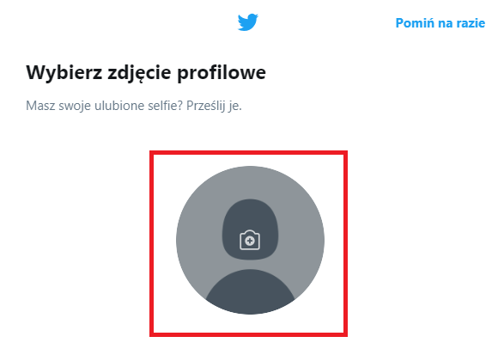
Source: own work
We upload the appropriate picture from our disk. It's best to have a clear photo of the face or, in the case of accounts for entities, a logo.
Figure 92. Uploading a profile picture
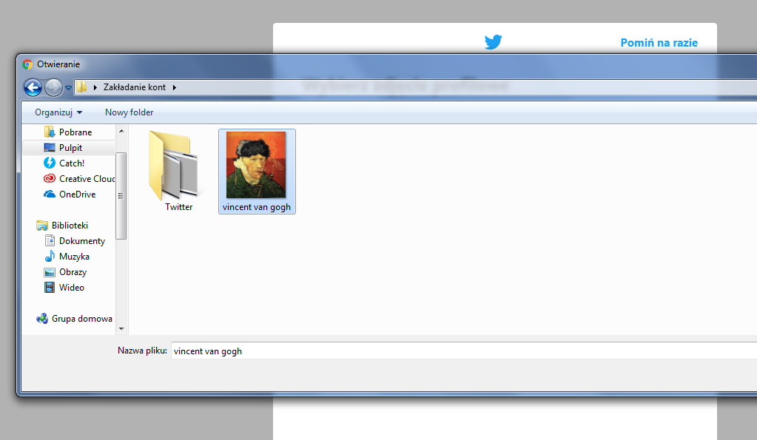
Source: own work
On the next subpage, we see a field in which we can write a few words about ourselves. It's good to write what we do and what we are interested in. Unfortunately, we have only 160 characters for the description.

Figure 93. Description of the Twitter account
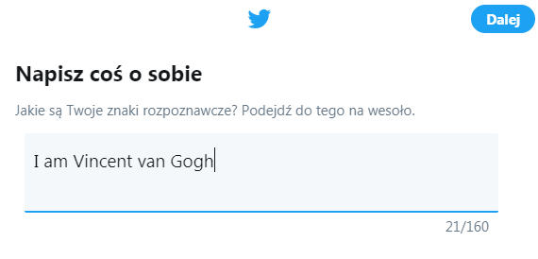
Source: own work
As with the LinkedIn portal, Twitter asks us if we want to import contacts from our mailbox. Doing this will allow us to create a basic network of contacts that will certainly facilitate our start in this new communication channel.
Figure 94. Importing contacts into a Twitter account
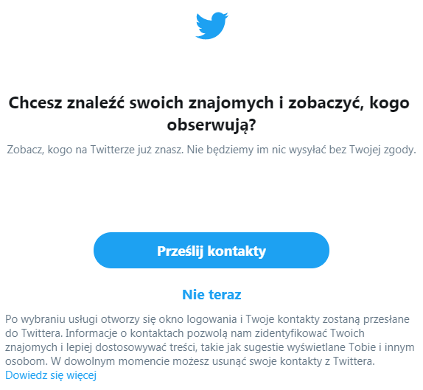
Source: own work
The final stage is to indicate the area of our interests. Enter a few letters in the available field and choose the most suitable categories.

Figure 95. Selection of interests
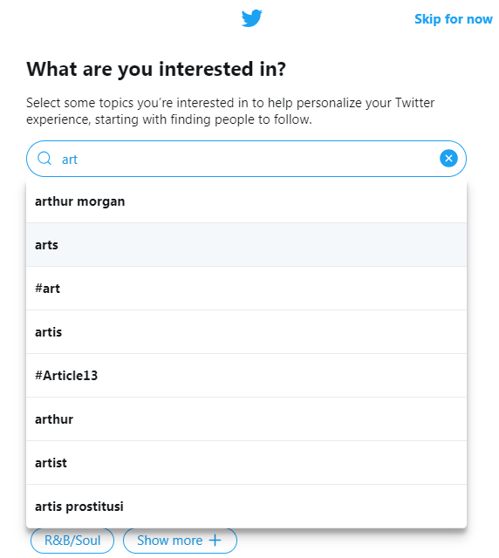
Source: own work
Well done, you have created your account on Twitter. In the next chapter, you will learn how to run your new profile to get the best results possible.

How to successfully run a Twitter account
The characteristic feature of Twitter is that the posts published on this channel are limited to only 140 characters long. Such a solution makes it an extremely dynamic medium, where what counts are neatly formulated opinions and up-to-date information. It is worth remembering this if you want to become part of this community. To make it even easier to start, you should also be aware of several principles that will allow us to reach as widely as possible with our content and provide us with the development of a network of relationships and contacts.

Figure 96. The principles for effectively running a profile on Twitter

Source: own work
The application of the indicated principles, as in the case of all social media, is only one part of effective communication. In addition to the ability to follow positive patterns, it is also necessary to eliminate potential errors that could negatively affect our activities.

Figure 97. Common Twitter users' errors

Source: own work based on https://socialpress.pl/2015/04/7-napopularniejszych-bledow-na-twitterze
In the right hands, social media is a powerful communication tool. It allows us to reach a very wide audience, build an image, make contacts and create whole communities. However, in order for our effectiveness to actually be so great, we should remember the need for conscious use of the various tools offered to us by social platforms.
At the very beginning, remember about the statistics. Nothing will tell us more about our recipients than they do. What made them curious and what made them angry; when they got involved and when they were silent; which time was the most suitable for a publication and which turned out to be a bad choice. Although there are many supposedly universal answers to such questions on the Internet, the most effective solution is the individualization of the message, which can only be done after analyzing the collected statistics.
We must not forget about the restrictions, especially those on Facebook. We should be aware that the times of easy organic reach have passed, so we are forced to either create extremely attractive content that will spread virally or bet on advertising. In the latter case, we should plan the sponsored campaign very carefully - since we are, after all, spending money on it.
Finally, it is worth mentioning other social networking sites. Instagram, LinkedIn and Twitter, although they undoubtedly do not have as many users as Facebook, they are still very important and worth considering. They each have their specific nature, so if you want to achieve certain specific career and development goals, they will sometimes be a much more effective tool than Facebook.
- Bibliography
- Alfred Lua, Decoding the Facebook Algorithm: A Fully Up-to-Date List of the Algorithm Factors and Changes, https://buffer.com/library/facebook-news-feed-algorithm,
- Alfred Lua, How to Use Facebook Insights and Analytics to Boost Your Social Media Marketing Strategy, https://buffer.com/library/facebook-insights,
- Alfred Lua, The Ideal Facebook Cover Photo Size And How To Make Yours Stand Out (Including 12 Excellent Examples), https://buffer.com/library/facebook-cover-photo,
- Chase Baker, How To: Create A Facebook Live Poll Video, http://social.colostate.edu/2017/03/06/how-to-create-a-facebook-live-poll-video/,
- Craig Bailey, CONTENT IS KING BY BILL GATES, https://www.craigbailey.net/content-is-king-by-bill-gates/,
- Facebook Analytics – an advanced tool from Facebook, https://www.ideoforce.pl/blog/facebook-analytics-zaawansowane-narzedzie-od-facebooka,46.html,
- Facebook Marketing Infographic, http://www.seobrands.com/facebook-infographic-mania/,
- Facebook-EdgeRank-Algorithm, https://fuelonline.com/social-media/facebook-marketing/facebook-edgerank-algorithm/,
- Felix Richter, Facebook remains the main gateway to online news, https://www.statista.com/chart/16304/social-media-as-a-news-source/
- Is Facebook Organic Reach Dead?, https://topdogsocialmedia.com/facebook-organic-reach-dead/,
- How can I hide and delete posts from my site?, https://www.facebook.com/help/252986458110193,
- Jakub Ozorowski, Facebook Pixel - what it is and how should we use it?, https://mobiletry.com/blog/facebook-pixel-co-to-jest,
- Jakub Prószyński, Mysteries of the EdgeRank – how to publish on Facebook, https://pijarukoksu.pl/tajemnice-edge-ranka-publikowac-facebooku.html,
- Joanna, What is a fanpage and how to set up a business account on Facebook, https://contweb.pl/social-media/co-to-jest-fanpage-i-jak-zalozyc-konto-firmowe-na-facebooku/,
- Laura Montells, What is Facebook EdgeRank or How Facebook Algorithm Works, https://metricool.com/what-is-facebook-edgerank-or-how-facebook-algorithm-works/,
- Małgorzata Kulka, How to read and analyze statistics on Facebook – a guide, https://socjomania.pl/jak-czytac-i-analizowac-statystyki-na-facebooku-poradnik-,
- Monika Kozłowska, How to check Facebook statistics and create reports, https://socialtigers.pl/blog/tworzenie-raportow-z-dzialan-na-facebooku,
- Mukesh Pandey, Facebook Organic Reach. What you need to know!, https://leadsdubai.com/facebook-organic-reach/,
- P. Temporal, Advanced Brand Management: Managing Brands in a Changing World, John Wiley & Sons, Singapore 2010,
- UMW Report, June 2016,
- Roles on pages, https://www.facebook.com/help/323502271070625?helpref=faq_content
- Scott Ayres, These 12 Viral Memes From Facebook Will Surely Make You Giggle, https://www.postplanner.com/most-viral-memes-posted-on-facebook/,
- Understanding & Increasing Facebook EdgeRank, https://www.socialbakers.com/blog/1304-understanding-increasing-facebook-edgerank.

Klaudia Witek, What is social media marketing and what opportunities does it offer?, https://www.eactive.pl/pozycjonowanie-stron/co-to-jest-social-media-marketing-i-jakie-oferuje-mozliwosci/, on 15.01.2019
Felix Richter, Facebook remains the main gateway to online news, https://www.statista.com/chart/1630 4/social-media-as-a-news-source/, on 15.01.2019
Instagram engages more than Facebook. How to use it in brand promotion, https://interaktywnie.com/biznes/artykuly/social-media/instagram-angazuje-bardziej-niz-facebook-jak-wykorzystac-to-w-promocji-marki-256465?page=4, on 15.01.2019
Alfred Lua, The Ideal Facebook Cover Photo Size And How To Make Yours Stand Out (Including 12 Excellent Examples), https://buffer.com/library/facebook-cover-photo, za dzień 14.12.2018
Role na stronach, https://www.facebook.com/help/323502271070625?helpref=faq_content, on 15.12.2018
How can I hide and delete posts from my page?, https://www.facebook.com/help/252986458110193, on 14.12.2018
Facebook Marketing Infographic, http://www.seobrands.com/facebook-infographic-mania/, on 15.12.2018
Facebook-EdgeRank-Algorithm, https://fuelonline.com/social-media/facebook-marketing/facebook-edgerank-algorithm/, on 15.12.2018
Jakub Prószyński, Mysteries of the EdgeRank – how to publish on Facebook, https://pijarukoksu.pl/tajemnice-edge-ranka-publikowac-facebooku.html, on 15.12.2018
Laura Montells, What is Facebook EdgeRank or How Facebook Algorithm Works, https://metricool.com/what-is-facebook-edgerank-or-how-facebook-algorithm-works/, on 15.12.2018
Understanding & Increasing Facebook EdgeRank, https://www.socialbakers.com/blog/1304-understanding-increasing-facebook-edgerank, on 15.12.2018
Alfred Lua, Decoding the Facebook Algorithm: A Fully Up-to-Date List of the Algorithm Factors and Changes, https://buffer.com/library/facebook-news-feed-algorithm, on 15.12.2018
Craig Bailey, CONTENT IS KING BY BILL GATES, https://www.craigbailey.net/content-is-king-by-bill-gates/, on 15.12.2018.
P. Temporal, Advanced Brand Management: Managing Brands in a Changing World, John Wiley & Sons, Singapore 2010.
Chase Baker, How To: Create A Facebook Live Poll Video, http://social.colostate.edu/2017/03/06/how-to-create-a-facebook-live-poll-video/, on 15.12.2018
UMW Report, June 2016, p. 13.
See 33 proven methods to get new followers on Instagram, http://blog.bloomboard.co/2018/04/26/poznaj-33-sprawdzone-metody-jak-zdobyc-nowych-followersow-na-instagramie/, on 16.01.2019.
Neil Patel, Instagram marketing: 7 errors that you should avoid at all costs, https://sprawnymarketing.pl/instagram-marketing-bledy/, on 16.01.2019.
7 tips on how to effectively use your LinkedIn profile, http://czaplicka.eu/7-rad-skutecznie-wykorzystac-profil-linkedin/, on 16.01.2019.
Jillian D'Onfro, Alyson Shontell, These errors should be avoided on LinkedIn, https://businessinsider.com.pl/rozwoj-osobisty/kariera/czego-nie-robic-na-portalu-linkedin-jakich-bledow-unikac/lqe0zhc, on 16.01.2019.
Małgorzata Kulka, How to read and analyze statistics on Facebook – a guide, https://socjomania.pl/jak-czytac-i-analizowac-statystyki-na-facebooku-poradnik-, on 15.12.2018.
Alfred Lua, How to Use Facebook Insights and Analytics to Boost Your Social Media Marketing Strategy, https://buffer.com/library/facebook-insights, on 15.12.2018
Małgorzata Kulka, How to read and analyze statistics on Facebook – a guide, https://socjomania.pl/jak-czytac-i-analizowac-statystyki-na-facebooku-poradnik-, on 15.12.2018
Alfred Lua, How to Use Facebook Insights and Analytics to Boost Your Social Media Marketing Strategy, https://buffer.com/library/facebook-insights, on 15.12.2018
Małgorzata Kulka, How to read and analyze statistics on Facebook – a guide, https://socjomania.pl/jak-czytac-i-analizowac-statystyki-na-facebooku-poradnik-, on 15.12.2018
Alfred Lua, How to Use Facebook Insights and Analytics to Boost Your Social Media Marketing Strategy, https://buffer.com/library/facebook-insights, on 15.12.2018
Alfred Lua, How to Use Facebook Insights and Analytics to Boost Your Social Media Marketing Strategy, https://buffer.com/library/facebook-insights, on 15.12.2018
Alfred Lua, How to Use Facebook Insights and Analytics to Boost Your Social Media Marketing Strategy, https://buffer.com/library/facebook-insights, on 15.12.2018
Alfred Lua, How to Use Facebook Insights and Analytics to Boost Your Social Media Marketing Strategy, https://buffer.com/library/facebook-insights, on 15.12.2018
Małgorzata Kulka, How to read and analyze statistics on Facebook – a guide, https://socjomania.pl/jak-czytac-i-analizowac-statystyki-na-facebooku-poradnik-, on 15.12.2018
Alfred Lua, How to Use Facebook Insights and Analytics to Boost Your Social Media Marketing Strategy, https://buffer.com/library/facebook-insights, on 15.12.2018
Monika Kozłowska, How to check Facebook statistics and create reports, https://socialtigers.pl/blog/tworzenie-raportow-z-dzialan-na-facebooku, on 15.12.2018
Jakub Ozorowski, Facebook Pixel - what it is and how should we use it?, https://mobiletry.com/blog/facebook-pixel-co-to-jest, on 15.12.2018
Facebook Analytics – an advanced tool from Facebook, https://www.ideoforce.pl/blog/facebook-analytics-zaawansowane-narzedzie-od-facebooka,46.html, on 15.12.2018
Is Facebook Organic Reach Dead?, https://topdogsocialmedia.com/facebook-organic-reach-dead/, on 15.12.2018
Scott Ayres, These 12 Viral Memes From Facebook Will Surely Make You Giggle, https://www.postplanner.com/most-viral-memes-posted-on-facebook/, on 15.12.2018
Joanna Dederko, 7 most common mistakes on Twitter, https://socialpress.pl/2015/04/7-napopularniejszych-bledow-na-twitterze, on 17.01.2019

